INVENTORY AND CHECK IN PREPARED FOR

FLAT A

40 QUEENS GATE TERRACE

LONDON

SW7 5PH

9TH JUNE 2020

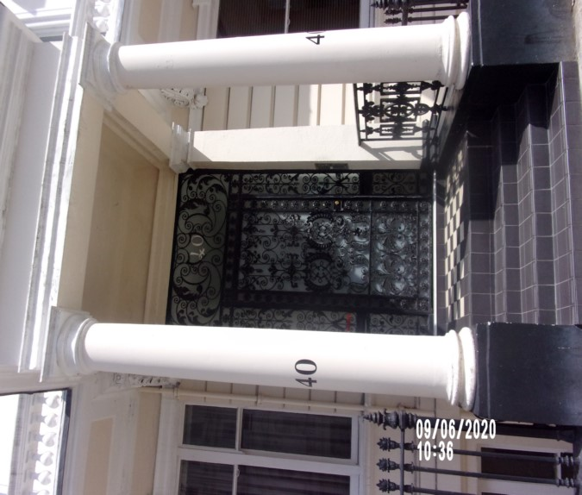

|  |  |
| --- | --- |
| **CLIENT:** | London Central Portfolio |
| **INSTRUCTED BY:** | Olivia Highwood |
| **JOB NO:** | 4189 |
| **REF:** | MBPS-002 |
| **INSPECTED BY:** | Janice Richardson |
| **PROPERTY SIZE:** | 1 Reception / 1 Bedroom / 1 Bathroom - Furnished Flat |



'WINDY RIDGE' [99 COWLEY HILL, BOREHAMWOOD, HERTS, WD6 5NA](https://maps.google.com/?q=99+COWLEY+HILL,+BOREHAMWOOD,+HERTS,+WD6+5NA&entry=gmail&source=g),TEL: 020 8 386 0950 - MOBILE: 077 67 647 647  
EMAIL: [info@inventorys.net](mailto:info@inventorys.net) [www.inventorys.net](http://www.inventorys.net/)  
Registered No: 4263261 VAT No: 822 9322 12

Safety Disclaimer

This inventory report is prepared as an ‘as seen snapshot’ of the property and its contents at the time of the designated inspection and is compiled as a fair and accurate record for the properties internal condition and contents. This does not form any part of a valuation or structural report.

This inventory is compiled on the basis that all items listed are in good order and clean. Any defects or soiling are noted where appropriate. Where inspections are carried out and the tenants’ belongings are in situ, it can be difficult for clerks to differentiate to that belonging to the landlord or tenant. Should the report contain inaccuracies the clerk (Independent Inventories (UK) Ltd) will not be held responsible.

The clerk preparing the inventory is not an expert in electrical appliances, antiques, furniture style, fabrics, flooring, etc. All descriptions within this report are for identification purposes only in order that each item can be compared to its condition at the commencement of the tenancy.

Lofts and Cellars are not included unless they are converted and safely accessible. Contents will therefore not be noted or checked at check-in or checkout.

Plants and shrubs will not be itemised.

Belongings left by the landlord/agent in a locked room or outbuilding will not be inventoried and are the sole responsibility of the Landlord/agent. Items in garages/sheds such as garden equipment and tools will be inventoried, however tins of paint will not be itemised.

We do not undertake to move heavy items of furniture or access lofts, high-level cupboards, or any other inaccessible places. Contents which have been left in the above-mentioned areas, which have not been inventoried, are the sole responsibility on the landlord. We also do not undertake to open windows, but will confirm whether keys have been seen or not.

Any electrical appliances tested will be for power only and only where practicable. The clerks are not qualified electricians and will only confirm the visual condition of the electrical socket, wiring and or fitting as seen. Boilers, Heating Systems, Gas Fires, Water Supply and Radiators are not tested, and Independent Inventories (UK) Ltd will not take any responsibility for units left either on or off even if on automatic timers. Where smoke alarms and CO Detectors are tested this is for power only and should not be taken to mean that the alarms are in full working order. We only state their presence and cannot state the functioning of this equipment. No responsibility is taken for any damage or malfunction occurring during the testing of such alarms.

The relevant utility companies must check all meter readings, as we cannot be held responsible for any discrepancies. We are not held liable should meters not be located or inaccessible to read. For Health and Safety reasons we do not expect our clerks to access high level areas which involve using ladders/chairs.

The Fire & safety Regulations regarding furnishings, gas, electrical & similar services are ultimately the responsibility of the instructing principle. Where the inventory notes FFR label seen, this should not be interpreted to mean that the item complies with the furniture & furnishings (fire) (safety) (Amendments) 1993. It is a record that the item had a label as described or similar to that detailed in the Guide to the regulations as published by the Department of Trade & Industry, January 1997, (or subsequent edition), attached at the time the inventory was complied.

Blinds in the premises are visually checked. We are unable to verify that the blinds comply with child safety requirements of BS EN 131202009 + A1:2014 placed on the manufacturer, supplier and professional installation of internal window blinds

It is the responsibility of the landlord/managing agent/tenant to agree between themselves the accuracy of the report, and Independent Inventories (UK) Ltd should be notified within 7 days of receipt of the report of any discrepancies within the report.

GENERAL GUIDANCE NOTES

Independent Inventories do not have sight of tenancy agreements or other agreements made between the tenant, landlord and management company. As these are guidance notes only it is always advisable that the tenancy agreement is cross referenced. This report will indicate whether in our opinion the tenant is liable for the deterioration or whether it is considered fair wear & tear. Independent Inventories may suggest maintenance, cleaning or tenant’s liability at checkout, but the final responsibility of these suggestions will fall with the landlord or managing agent in respect of the original tenancy agreement. We do not suggest costs of any items, these should be sourced from the relevant contractors by the landlord or managing agent.

CLEANING

We recommend that a professional cleaning company is employed at the end of the tenancy, unless alternative arrangements have been agreed with the Landlord/Managing Agent. Receipts from professional cleaning and carpet cleaning companies must be present to the clerk at the checkout inspection.

If the standard of cleaning is not satisfactory most Landlords/Managing Agents will contract a cleaner and their charges will be charged to the tenant unless otherwise stated in the tenancy agreement.

DECORATION

It is accepted that during the course of the day to day living scuffs will appear on walls and woodwork. However, should the marks be found to be excessive charges will be made to you the tenant, unless otherwise stated in the tenancy agreement.

LIGHTING

If the lights are working at check-in then it is normal, if lights are not working at checkout, for these to be the responsibility of the tenant to replace bulbs or to be charged accordingly, unless otherwise stated in the tenancy agreement.

GARDENS/PATIO

If the standard of the garden/patio is found to be untidy compared to the start of the tenancy the Landlord/Managing Agent are entitled to employ a contract gardener and the charge will be made to you the tenant, unless otherwise stated in the tenancy agreement.

MAINTENANCE ISSUES

We recommended should any maintenance issues arise you contact the Landlord/Managing Agent immediately so they can deal with the matter. Should we recommend items require maintenance once a property has been checked out, this is purely stating that an item will require fixing/attention, we are not advising as to whose responsibility this and your tenancy agreement will need to be checked.

CHANGES TO PROPERTY

We recommend that if you wish to make any changes to the décor or remove any of the Landlords belongings you contact the Landlord/Managing Agent for permission and have this confirmed in writing to ensure there are no discrepancies at the end of the tenancy.

TENANTS INFORMATION FOR CHECKING OUT OF PROPERTY

It is important at the checkout that:

1. All cleaning should be completed prior to the checkout appointment as per the tenancy agreement.
2. All personal items must be removed prior to the check out.
3. All items should be in the same location as per the inventory, any stored items should be unpacked and also returned to the same location.
4. If the Inventory clerk has to search for items or you still have belongings in the property to be removed this will result in additional charges being made to the tenant.
5. All beds should be left unmade with the linen folded. Bedding & towels should be cleaned & ironed where relevant.
6. All food items should be removed, freezers defrosted & doors left open & electricity turned off.
7. All light bulbs etc. should all be in working order as at check in.

The property should be left in a clean and tidy condition especially carpets, curtains, windows, upholstery appliances etc. We would suggest that you refer to your tenancy agreement in this matter.

If you are not ready to leave it may not be possible to carry out the checkout. In this case a return visit will be necessary resulting in a cancellation charge.

All keys to the property must be handed over at the time of checking out to the Inventory clerk or alternatively to the agents prior to the checkout taking place.

The Inventory Clerk acts as an independent and reasonable body and will avoid unnecessary criticism or derogatory comments when compiling or checking the Inventory.

At the termination of the tenancy the inventory will be checked and any obvious or significant discrepancies will be reported to the Managing Agent/Instructing Principal. This report will indicate whether in our opinion the tenant is liable for the deterioration or whether it is considered fair wear &tear. Normal fair wear and tear will be assessed on the lengthy of the tenancy and type occupancy.

INDEX

PAGE

|  |  |
| --- | --- |
| UTILITY READING | 1-2 |
|  |  |
| KEYS | 3 |
|  |  |
| GENERAL SUMMARY AT CHECKIN | 4 |
|  |  |
| INSTRUCTION MANUALS | 5 |
|  |  |
| ENTRANCE HALLWAY | 6-11 |
|  |  |
| BEDROOM | 12-20 |
|  |  |
| RECEPTION ROOM | 21-29 |
|  |  |
| KITCHEN | 30-40 |
|  |  |
| SHOWER ROOM | 41-47 |
|  |  |
| DECLARATION AT CHECK IN | 48 |
|  |  |
| ADDITIONAL AMENDMENTS | 49 |
|  |  |
| SIGNED SCHEDULE OF CONDIITON AT CHECK IN | 50-57 |

**UTILITY READINGS / KEY LIST& INSTRUCTION MANUALS**

|  |  |  |
| --- | --- | --- |
| **ELECTRIC** | **GAS** | **WATER** |
| METER NUMBER:  L86A15988 | METER NUMBER:  Not located | METER NUMBER:  Not located |
| READING:  Low: 64692  Normal: 37965 | READING:  Not located | READING:  Not located |
| LOCATION:  Communal hall on entry | LOCATION:  Not located | LOCATION:  Not located |

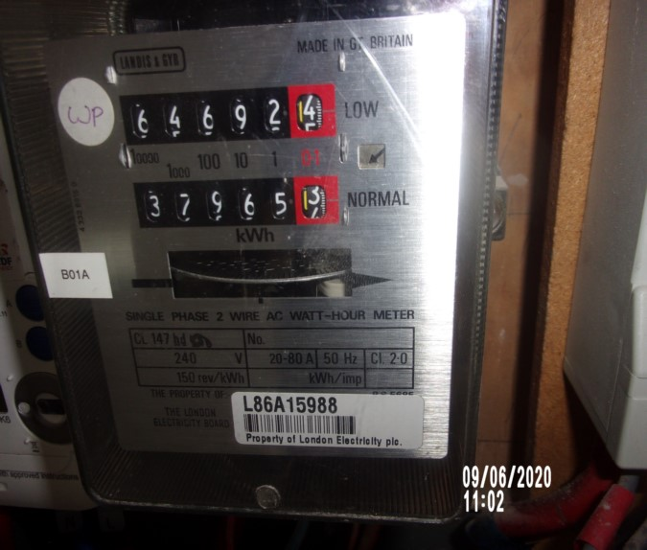

|  |
| --- |
| **LOCATION OF:** |

|  |  |  |
| --- | --- | --- |
| **STOP COCK** | Bathroom low level cupboard | |
| **FUSE BOARD** | Hallway high level cupboard | |
| **ALARM PANEL**  **This has not been tested** | None seen | MAKE: |

|  |
| --- |
| **FIRE SAFETY** |

|  |  |
| --- | --- |
| **SMOKE ALARM 1** | Not visible  Tested with canned smoke and working order  Location: Hallway |
| **SMOKE ALARM 2** | Not visible  Tested with canned smoke and working order  Location: Hallway |
| **CARBON MONOXIDE ALARM** | Not seen |

|  |  |  |
| --- | --- | --- |
| **KEYS AT CHECKIN** | **KEYS AT CHECKOUT** | |
| **KEY TYPE / SERIAL NUMBER / QTY** | **KEY TYPE / SERIAL NUMBER / QTY** |
| 1 x JMA Yale |  |
| 2 x Banham flat door (0587385) |  |
| 2 x Banham (64D5708) |  |
|  |  |
|  |  |
|  |  |
| **KEYS RECEIVED BY: Tenant**  E:\Preetha\FILES\II\JUNE - 2020\9TH JUNE\FLAT A, 40 QUEENS GATE TER - IN\71 Photos A  40 queens gate terrace\70 keys.JPG | **KEYS RETURNED TO:** | |

|  |
| --- |
| **GENERAL SUMMARY** |

|  |  |  |
| --- | --- | --- |
| **ITEM** | **CHECKIN NOTES** | **CHECKOUT NOTES** |

|  |  |  |  |
| --- | --- | --- | --- |
| **GENERAL CONDITION** | | Professionally cleaned for start of tenancy , some further cleaning required |  |
| **ODOUR** | | N/A |  |
| **DECORATIVE ORDER / WOODWORK** | | Defects as noted  Woodwork scuffed/ chipped |  |
| **FLOORING** | | Defects as noted  Vacuumed for start of tenancy |  |
| **CURTAINS / BLINDS** | | Requires further cleaning  Defects as noted |  |
| **BLIND REGULATIONS** | | Regulations not met |  |
| **UPHOLSTERY** | | Vacuumed in situ for start of tenancy  Defects as noted |  |
| **FFR LABELS** | Sofa FFR label not seen  Armchair FFR label not seen  Bedroom 1 FFR label not seen  Client informed name Olivia Highwood | |  |
| **LINEN** | None provided | |  |
| **LIGHTS** | Bulbs not working – 2 x reception, 1 x floor light and 1 x kitchen | |  |
| **KITCHEN/ APPLIANCES** | All appliances power tested except microwave  Fridge/freezer left shut power on  Final wipe required | |  |
| **BATHROOMS/**  **WC** | Water outlets tested and working WC flush  Mildew to areas as noted | |  |

|  |  |  |
| --- | --- | --- |
| **WINDOWS** | Fitments complete  Clean to interior  Requires further cleaning  Not closing properly reception |  |
| **GARDEN /**  **TERRACE** | N/A |  |

|  |  |
| --- | --- |
| **MANUALS SUPPLIED AT**  **CHECKIN** | **MANUALS RETURNED AT**  **CHECKOUT** |
| **APPLIANCE/ MAKE** | **APPLIANCE/MAKE** |
| WITHIn report on page |  |
|  |  |
|  |  |
|  |  |

 *N.B – Heavy items will not be moved or inspected behind/under, for health & safety reasons. We will not be held liable should any damages/stains/marks be found during the tenancy in these areas. Should the occupant find any of the above they should, inform the landlord/agent immediately and if/where possible take photographic evidence and pass to the relevant parties.

 This camera symbol throughout the Inventory check in/out indicates where a photo has been taken. Photos can be found at the back of each room in the report with the relevant headings

# ENTRANCE HALLWAY

|  |  |  |  |
| --- | --- | --- | --- |
| **Front Door** | Door Frame Exterior  Painted white  Draught excluder | Discoloured  Few minor scuffs to low level  Indent to low level from door handle  Heavily discoloured to edges  Light scuffs seen in places left and right-hand side mid to low level |  |
|  | Door Exterior  White painted flush door  Painted over screw covers  Chrome Banham lock and finger pull  Further Chrome Banham lock | Very minor splash stain mark to the centre of the door  2. Painted over defects  3. 1 or 2 minor paint marks to Banham lock  4. Good order  Shading seen around the edges  Light scuffing seen at low-level |  |
|  | Door Frame Interior  Painted white | Appear to be intact and in good order |  |

# ENTRANCE HALLWAY

|  |  |  |  |
| --- | --- | --- | --- |
| **Door contd..,** | Door Interior  White painted flush door  Chrome Banham barrel lock  Further Chrome Banham lock  Draught excluder to base  Yale top lock with 2 x keys  Chain and keep | 1 or 2 x light scuffs seen low-level  Patchy paint work seen in places |  |
| **Ceiling & Coving** | Painted white  White painted coving  1 x Water sprinkler  1 x Smoke detector | Odd chip and scuff around light  Not tested  Tested and working  Green light seen |  |
| **Lighting** | 2 x White rimmed halogen bulbs | Both working order |  |
| **Walls** | Painted pale grey | Painted over defects  Door stop recommended  Few light mid to low level marks  Indent behind door from lock  Left hand side corner has a chip mark and a few rub marks at mid-level  Not inspect behind furniture |  |

# ENTRANCE HALLWAY

|  |  |  |  |
| --- | --- | --- | --- |
| **Skirting** | Skirting painted white | Minor scuffs |  |
| **Flooring** | Light wood panelled flooring |  |  |
| **Switches & Sockets** | White plastic / chrome | Good order |  |
| **Built in cupboard** | Pale grey flush high-level cupboard  Fuse box interior | Finger soil to exterior door |  |
| **Poster** | Wall mounted dark framed poster in terracotta/beige colouring | 1. Chip to frame left hand side edge high level  Unglazed |  |
| **Console table** | White / black console table | Good order  1 or 2 x small scuffs to edges |  |
| **Coffee table** | Small white and black coffee table | Reasonably good order  Odd chip |  |

# ENTRANCE HALLWAY

|  |  |  |  |
| --- | --- | --- | --- |
| **Entry phone** | Wall mounted cream entry phone by ‘Atel’ | 1. Tested and working  2. Coil soiled |  |
| **Dish** | Bronze coloured leaf-shape dish | In use  1 x chip to edge  Selection of letters |  |
| **Picture** | Picture of Bourbon street with black frame | Few scratches / chips to frame |  |
|  | Metal clothes airer  Vileda red handled mop |  |  |

Flat door Keys interior door

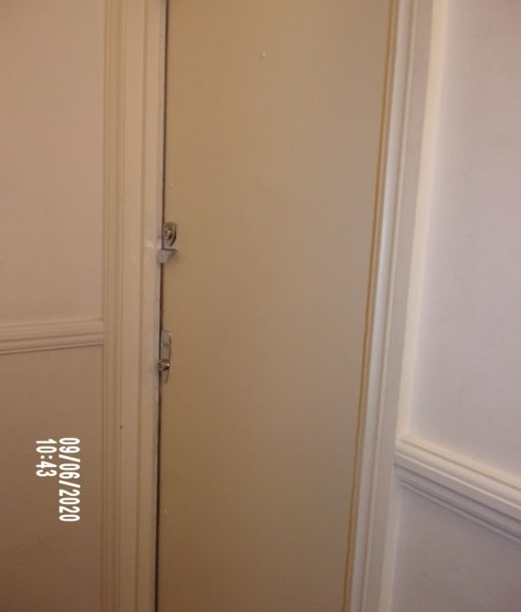 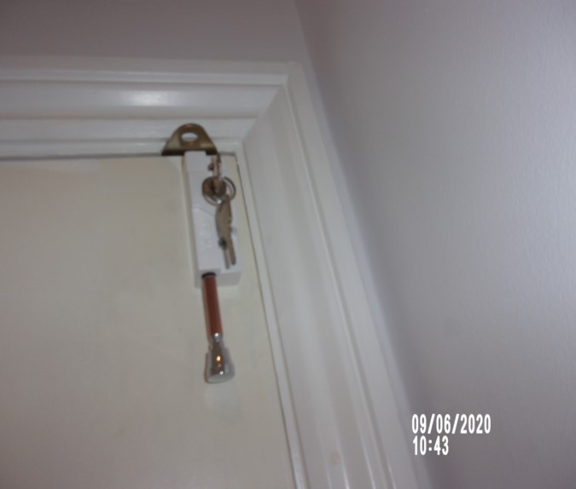

Hallway Hallway

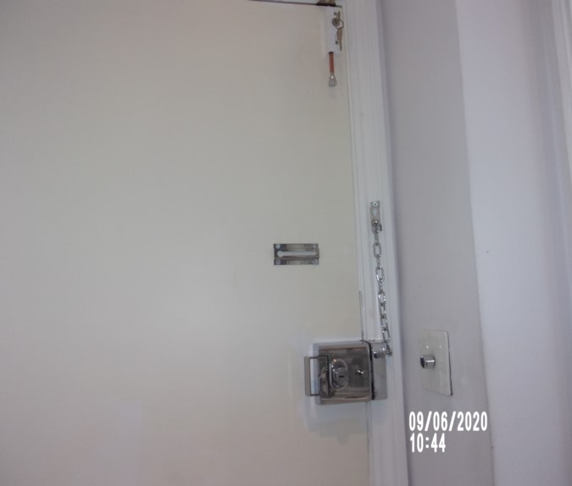 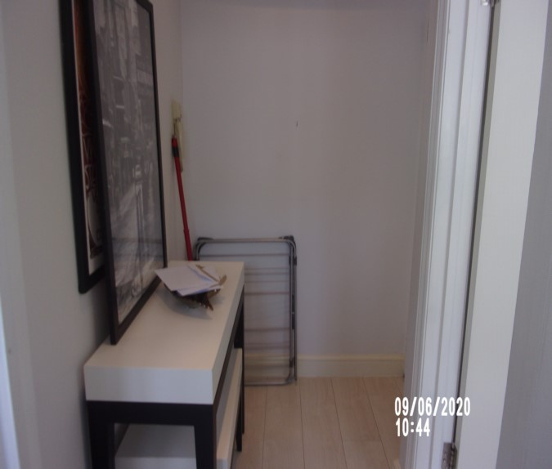

Hallway Smoke alarm

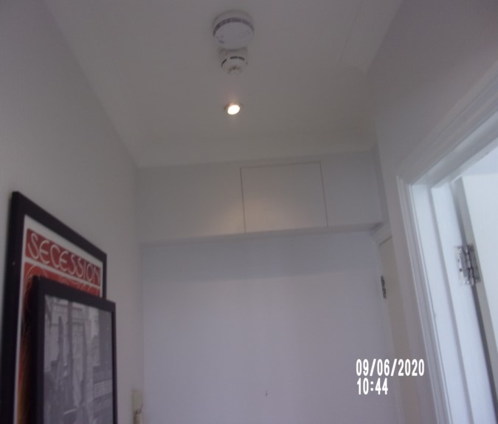 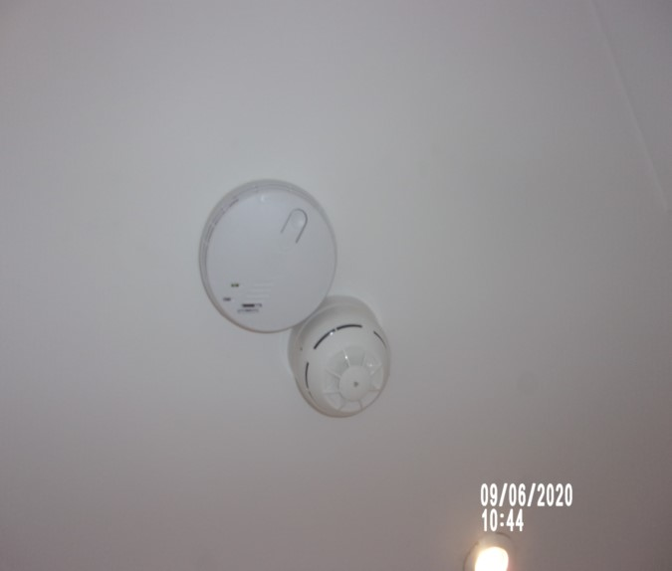

Walls Pictures

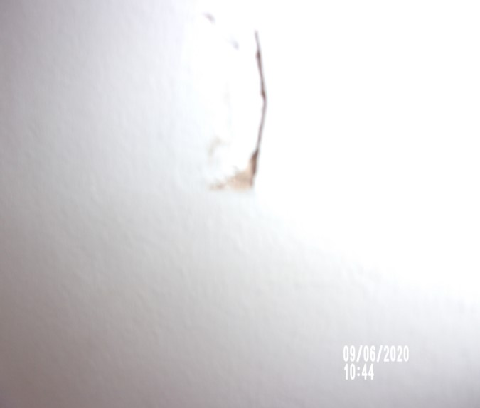 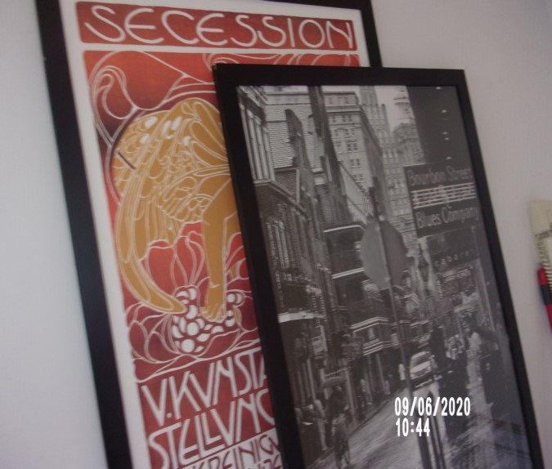

Scuff to wall

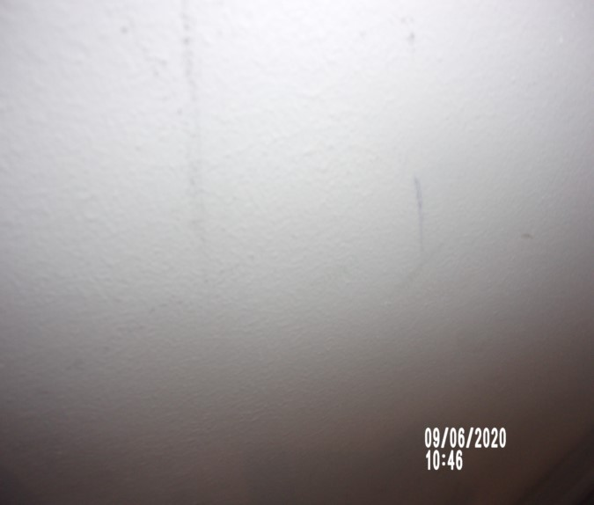

# BEDROOM

|  |  |  |  |
| --- | --- | --- | --- |
| **Door** | Door Frame Exterior  Painted white | 1. Painted over chip to left side high level  Intact |  |
|  | Door Exterior  White painted flush door with brushed steel lever handle | 2. Good order  1 or 2 x light scuffs to low level exterior  Long black rubs to mid-level  Further rubs to low level  Some chipping seen to the top edge at an angle |  |
|  | Door Frame Interior  Painted white | Some scuffing to high level of framework interior  Chip to high level of framework interior  Chipping seen to the underside of crossbar |  |
|  | Door Interior  White painted flush door with brushed steel lever handle | Over door metal hanger  Odd scuff mid to low level |  |

# BEDROOM

|  |  |  |  |
| --- | --- | --- | --- |
| **Ceiling & Coving** | Painted white  White painted coving | Appear to be intact |  |
| **Lighting** | 4 x White rimmed halogen bulbs  2 x Brushed steel wall mounted lights with cream shades | All working order  Both in working order  1 x screw missing from left-hand side wall mounted light |  |
| **Walls** | Painted pale grey | 1. Painted plaster pop to left hand side of entry mid-level  3. Some slight cracking at mid/low level left side of radiator  4. Not inspected behind bed  Few light mid to low level marks  Rubs to low level on the left-hand side wall and on the right hand side wall  Water damage to right of radiator low level  Ring marks and other marks to shelves within bed recess  Greasy spots to walls within recess  Cracking to corners of left-hand side and facing wall  Stress crack above door  Some chipping seen to fuse socket to rear facing wall |  |

# BEDROOM

|  |  |  |  |
| --- | --- | --- | --- |
| **Skirting** | Skirting painted white | Few minor scuffs  Hairline cracking seen to the top surface |  |
| **Flooring** | Light wood panelled flooring  Brushed steel / black rubber door stop fitted | Slightly bowed to the left hand side and creaking  2. Not inspected below bed  3. Good order  Secure  Not inspected underneath any furniture |  |
| **Windows** | White painted frame casement window  1 x Arched glazed fixed panel  2 x Opening casement windows  2 x Brushed steel levers  1 x Chrome arm  1 x Brushed steel slide and bolt lock  White painted sill | 2. Glazing clean to interior  Soiled to exterior  Frames deteriorating  Slight paint cracking  Mould residue along the edges of the frame in places  Cracking seen to paint work throughout the edges  Water stain left-hand side  Paint cracking to edges and middle of sill |  |

# BEDROOM

|  |  |  |  |
| --- | --- | --- | --- |
| **Curtains** | Cream black out blind with white beaded pulley  Break connector to pulley | Fraying to left hand side with loose threads  Some soiling to low level  Not working  Unable to raise  Beaded chain is missing– maintenance required |  |
| **Heating** | Black painted radiator set behind cream painted radiator cover | Radiator not closely inspected / working order  Front cover some grey shading in places  Residue masking tape above left-hand side cover  Right-hand side cover is loose |  |
| **Built in cupboards** | Range of white laminate flush fronted built in cupboards with brushed steel pulls  Interior  Painted cream | General marks consistent with use |  |
| **Inspected from left hand side** |  |  |  |
| **Cupboard 1** | Single cupboard  Interior  6 x Shelves  1 x Electronic safe  Model No. EX2005282721and key | Some light usage marking to interior  Minor rubs to the edge of the exterior door by handle |  |

# BEDROOM

|  |  |  |  |
| --- | --- | --- | --- |
| **Cupboard 2** | Corner cupboard  Interior  2 x Shelves | Cupboard order  Some light usage marking to interior  Central hinge not attached to unit body  Lower shelf has some rubs, usage and wear |  |
| **Cupboard 3** | Single cupboard  Interior  3 x Shelves  1 x Chrome hanging rail  Cream painted boxed in section | 1. 4 x Further old fitment holes  2. Paint work slightly patchy to mid level shelf with circular paint pot ring mark  Some light usage marking to interior |  |
| **Cupboard 4** | Double cupboard  Interior  Painted cream  3 x Shelves  1 x Chrome hanging rail  Further cream painted boxed in section | Good order  Some light usage marking to interior |  |
| **Cupboard 5** | Shaped cupboard with pull down door  Interior  Painted cream | Sticky residue marks  Odd scuff to interior |  |

# BEDROOM

|  |  |  |  |
| --- | --- | --- | --- |
| **Switches & Sockets** | White plastic / chrome |  |  |
| **Shelves** | 2 x Cream painted recessed shelves by bed | Scuffs to base and walls |  |
| **Bed** | Double divan with black / white divan base  Mattress | Good order  Signs of light wear  Fire label not seen  Pulls to fabric  Label side examined only |  |
|  | Cream faux leather headboard with button studs | Appears in good order |  |
| **Chair** | 2 x brown fabric dining chairs on wooden legs | Used order  FFR label seen |  |

Bedroom Bedroom

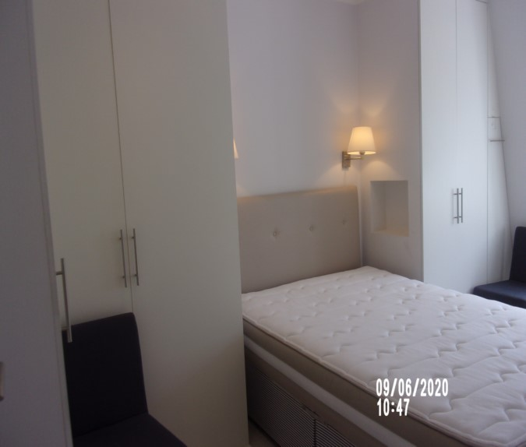 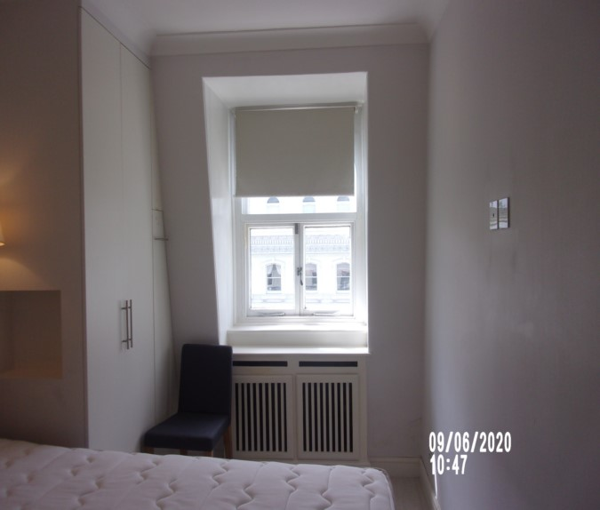

Bedroom Residue cupboard door

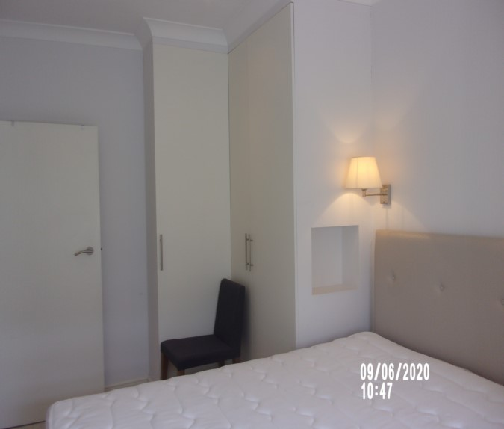 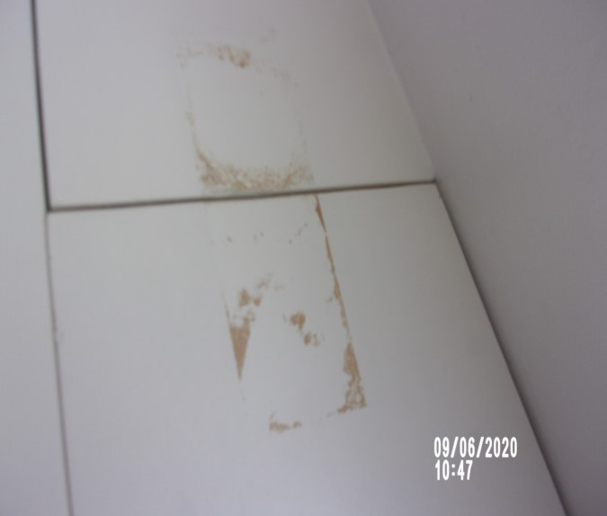

Water stain to wall Blind

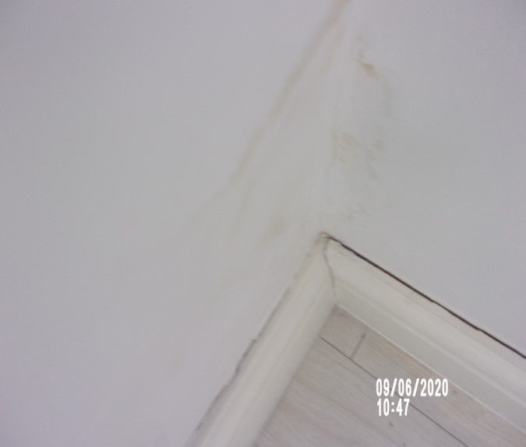 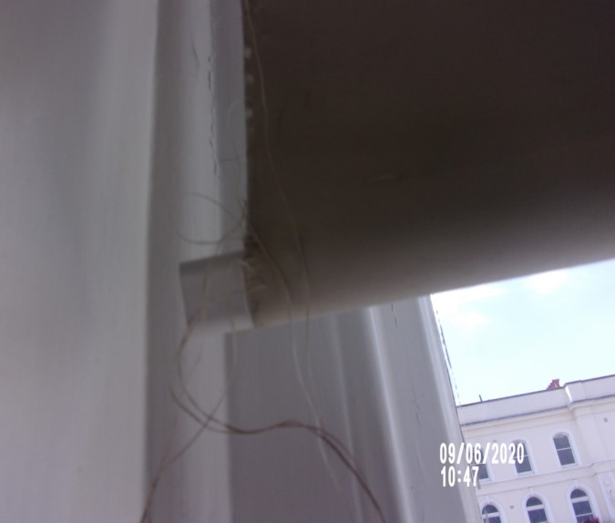

Window Scuff window blind

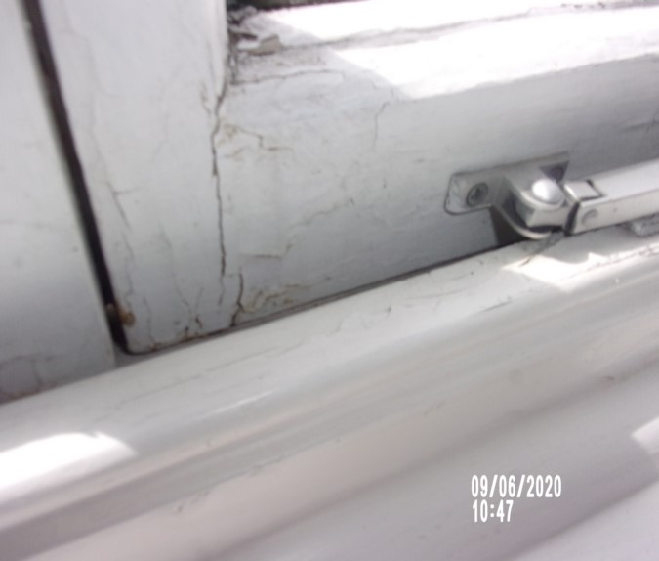 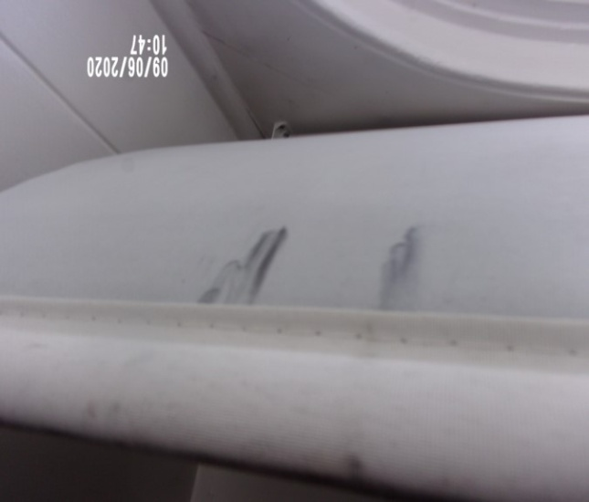

Radiator panel Screw missing light fitting

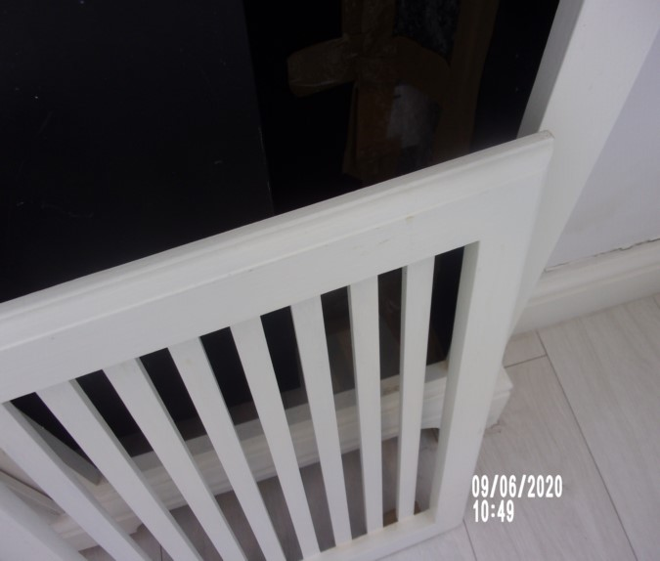 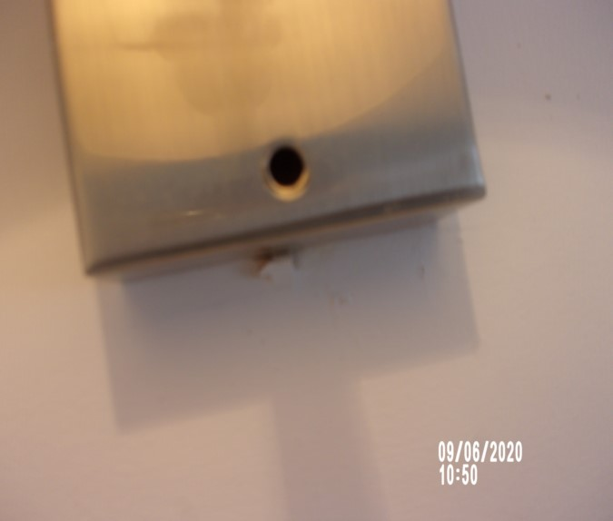

Walls Cupboard 1

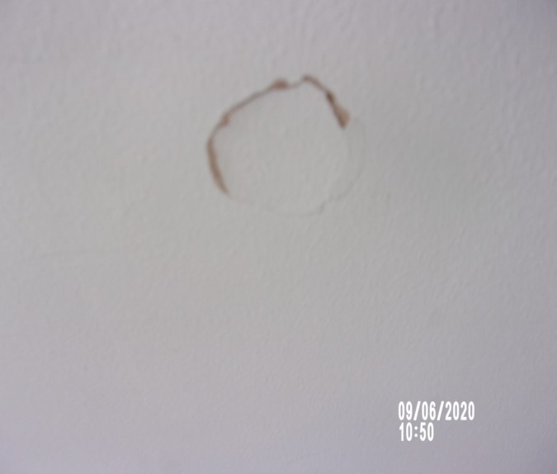 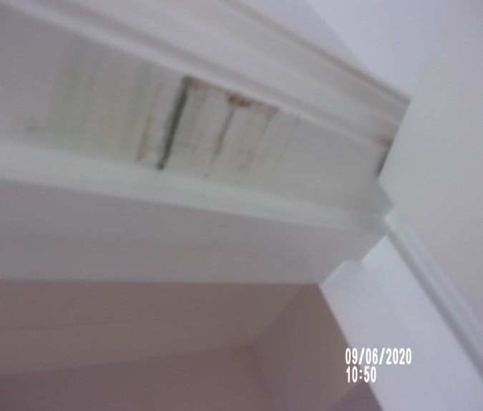

Cupboard 2 Hinge detach cupboard door

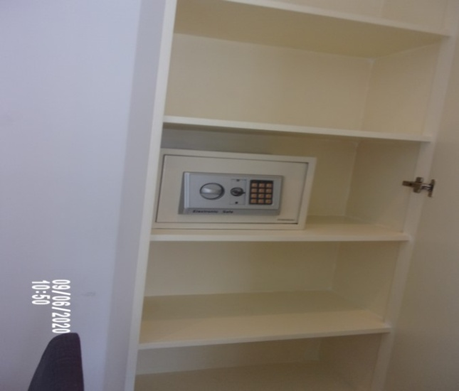 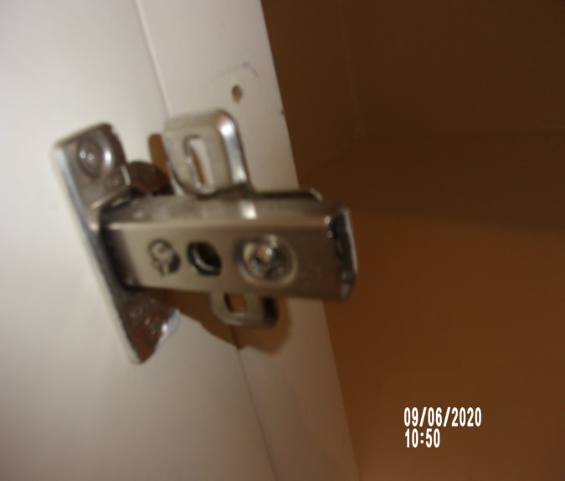

Cupboard 3 Cupboard 4

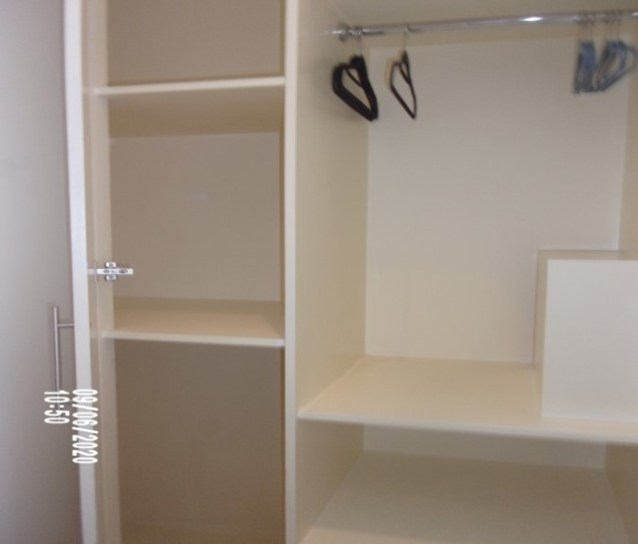 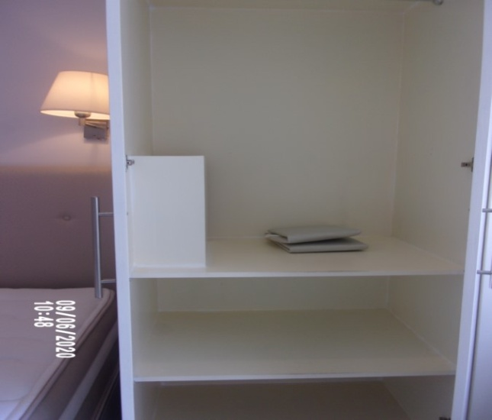

Cupboard 5

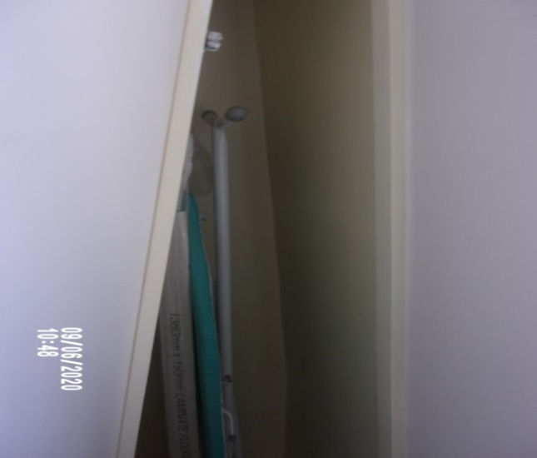

# RECEPTION ROOM

|  |  |  |  |
| --- | --- | --- | --- |
| **Door** | Door Frame Exterior  Painted white | 1 or 2 x chips and scuffs seen left-hand side mid to low level |  |
|  | Door Exterior  White painted flush door with brushed steel lever handle | 2. Good order  3. Couple of white speckled paint marks to handle  1 or 2 x light scuffs seen in places mid to low level |  |
|  | Door Frame Interior  Painted white | Some light chipping seen left-hand side mid to low level |  |
|  | Door Interior  White painted flush door with brushed steel lever handle | Inside edge has a red mark to low level  2. Few minor paint speckled marks  Some light scuffing seen low-level |  |
| **Ceiling & Coving** | Painted white  White painted coving | Good order  Painted over defects, especially around light fittings  Finger soil marks around recessed lights in places |  |

# RECEPTION ROOM

|  |  |  |  |
| --- | --- | --- | --- |
| **Lighting** | 6 x White rimmed halogen bulbs | Only 4 x currently showing for power |  |
| **Walls** | Painted pale grey | Few light mid to low level marks  2 x adhesive pad residues, 1 x with broken hook to right hand side  1 x small dark scuff to rear right corner  Right wall has black mark  1 x stainless steel hook to wall behind door  1 x chip near steel hook  Mid to low level furniture marks  Front facing and left-hand side wall some water damage seen in places  Left-hand side wall some chipping seen to paint work near coat hook  1 x white plastic hook left-hand side |  |

# RECEPTION ROOM

|  |  |  |  |
| --- | --- | --- | --- |
| **Skirting** | Skirting painted white | 1. Good order  2. Not inspected behind furniture  Few scattered minor scuffs |  |
| **Flooring** | Light wood panelled flooring  Brushed steel / black rubber door stop fitted | 1. good order  2. Not inspected below furniture  1 or 2 x Tiny edge chips towards centre |  |
| **Switches & Sockets** | White plastic / chrome | Good order  Facing wall socket cracked |  |
| **Window 1** | White painted frame casement window  3 x Opening casement windows  3 x Chrome levers  2 x Chrome arms  White painted sill | 1. Glazing clean to interior  Frame deteriorating  Chipping and paint flaking  Soiled to exteriors  Paint chipping  All windows cracking and flaking to paint work  Sill flaking to paint work  Mould patches to corners |  |

# RECEPTION ROOM

|  |  |  |  |
| --- | --- | --- | --- |
| **Window 2** | White painted frame with arched fixed panel  2 x Opening casement windows with 2-brushed steel levers  1 x Chrome arm  1 x Brushed steel slide and bolt  White painted sill  Painted over cable / junction box to right hand side | 1. Glazing clean to interior  Frame deteriorating – needs attention  Further deterioration of frames and paintwork  Painted over defects  Heavy cracking to windowsill  Window not fully closing  Gap to base |  |
| **Blind** | Cream black out blind with white beaded pulley  Break connector to pulley | 1. Working order  2. Fraying heavily to left hand side edge also to right-hand side wooden support – needs fitting to blind  3. Slightly soiled to low level  Plastic fitting to the right-hand side has become detached  Pulley repaired with tape  Beaded chain has come loose not operating maintenance required  Staining seen to sections at low-level |  |

# RECEPTION ROOM

|  |  |  |  |
| --- | --- | --- | --- |
| **Heating** | Black painted radiator with white painted radiator cover | 2. Left hand side cover panel appears slightly loose  3. Not closely inspected  Grey shading seen to the front surface  Sellotape on panel |  |
| **Shelf area** | White painted recess shelf area  4 x White painted shelves | Some painted over defects to right hand side top shelf  Usage to shelves |  |
| **Lift up tables** | 2 x White painted lift up tables attached to wall | Showing few very light usage marks  Slight discolouration to corner |  |
| **Map** | Wall mounted black framed map of world | Good order  Unglazed |  |
| **Dining table** | Glass circular topped dining table with brushed steel pedestal base | 1 or 2 minor marks to base  Some light surface scratching to glass |  |

# RECEPTION ROOM

|  |  |  |  |
| --- | --- | --- | --- |
| **Dining chairs** | 2 x grey fabric dining chairs on wooden legs to match | Used order  1 x slightly unstable  1 x base cushion has a white stain approximately 1”- 1 x has green stain  Slight mark to one back  Fabric pulling  General staining seen to the top surface in places – further cleaning required |  |
| **Sofa** | 3-seater taupe coloured sofa set on wooden legs in separate sections / pushed together:-  2 x Arm sections  1 x Single section  3 x Seat cushions | 1. FFR label not seen  Light usage to the base cushions and on the right-hand side arm slight discolouration  Feet may need attention – requires fixing screw loose |  |
| **Pouffe** | Matching large pouffe with separate top | Signs of light wear |  |
| **Scatter cushions** | 1 x brown crushed velvet scatter cushion  1 x Pale grey self-patterned scatter cushion  3 x Black / grey matching scatter cushions | All in use  Cleaning required |  |

# RECEPTION ROOM

|  |  |  |  |
| --- | --- | --- | --- |
| **Light** | Brushed steel floor mounted light with grey fabric shade | Not working |  |
| **Rug** | Grey rectangular rug | In use |  |

Reception Reception

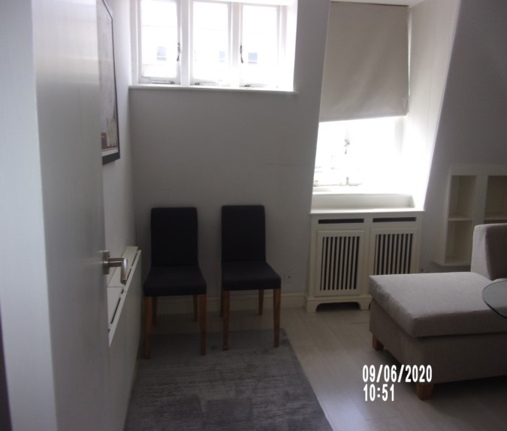 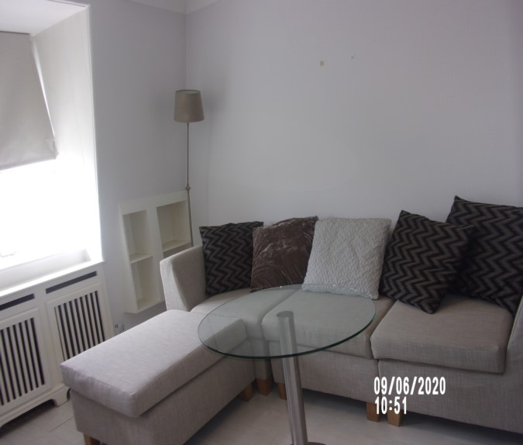

Reception Fold down tables

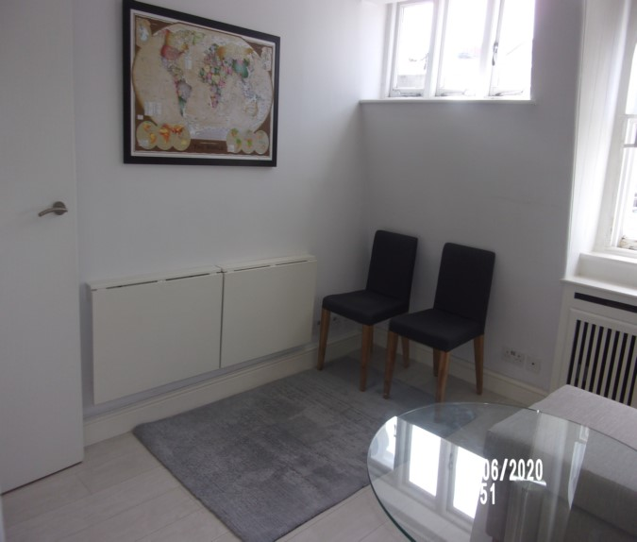 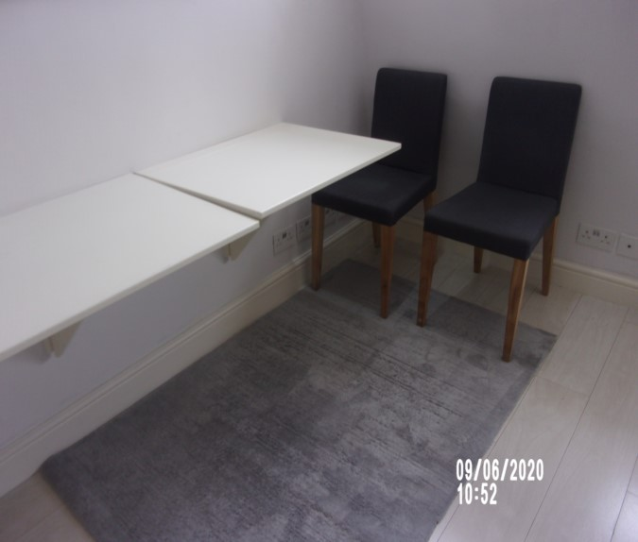

Scuff wall Window

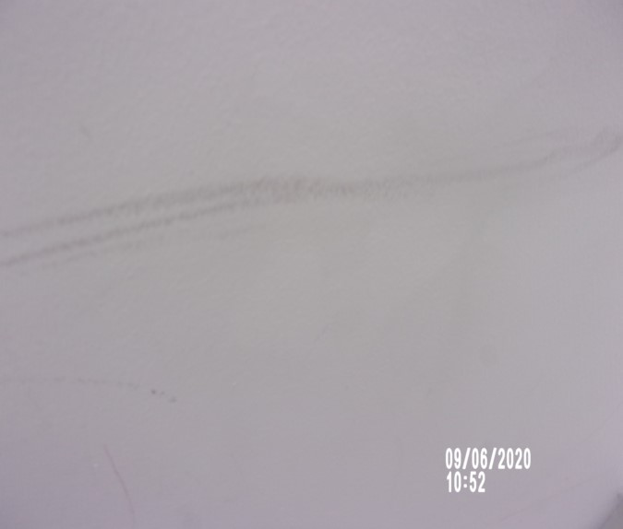 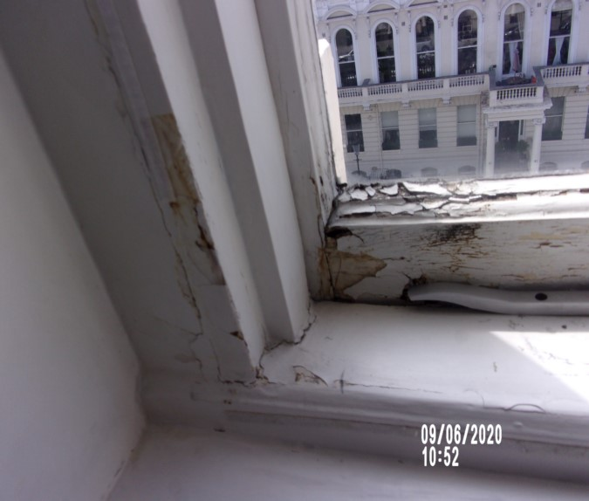

Socket crack Fraying to blind

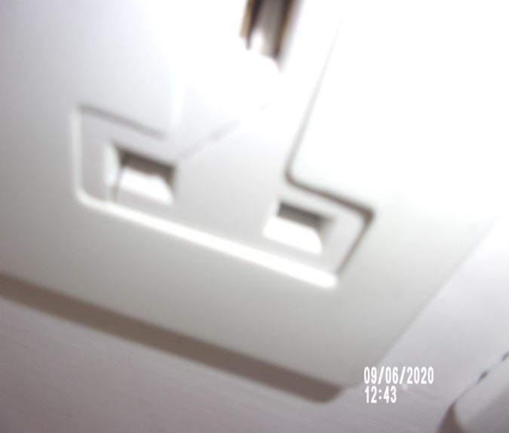 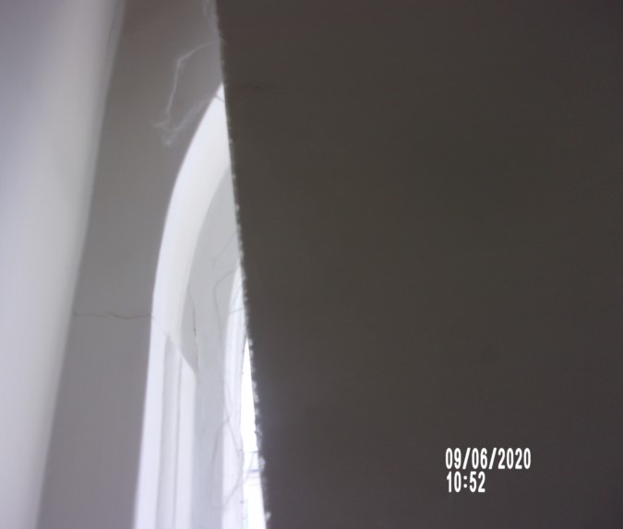

Blind cord detached Window

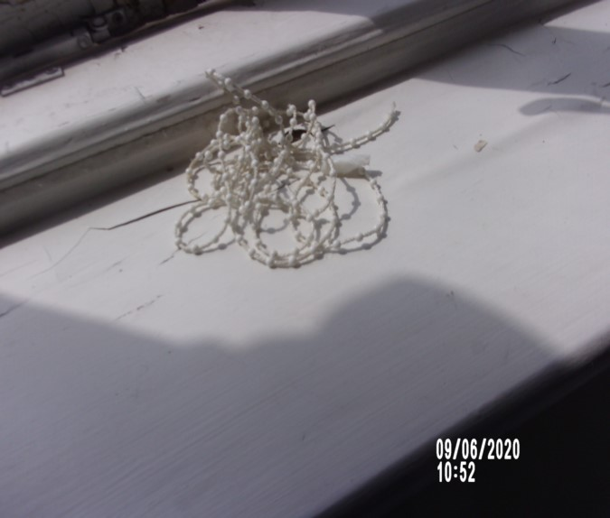 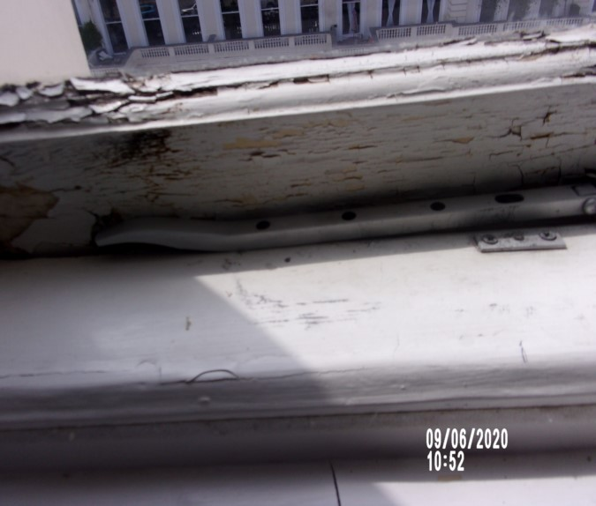

Windowsill Chair seat stain

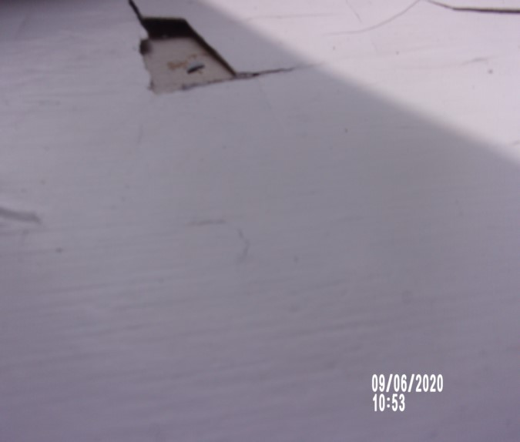 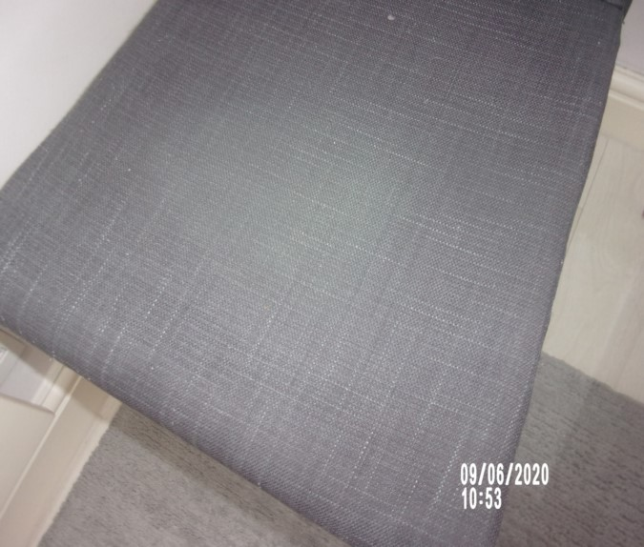

Mould window

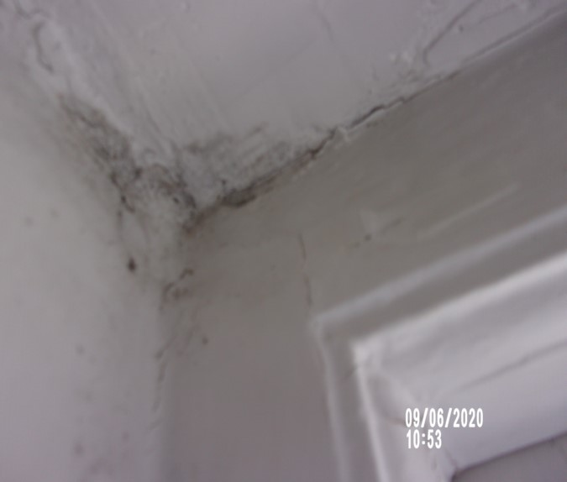

**KITCHEN**

|  |  |  |  |
| --- | --- | --- | --- |
| **Door** | Open plan from Reception |  |  |
| **Ceiling** | Painted white  1 x small mark | Good order  Painted over defects |  |
| **Lighting** | 2 x White rimmed halogen bulbs | 1 x not currently showing for power |  |
| **Skirting** | Painted white | Chipping and scuffing in places |  |
| **Flooring** | Large off-white ceramic tiles | Grouting slightly discoloured  Some slight shaded marks specially to centre  Shaded towards edges of tiles  Centre tile on entry has multiple hairline crack and large crack and chip  2 x further chipped tiles near shower room  General Discolouration  Heavy cracking to grout |  |

**KITCHEN**

|  |  |  |  |
| --- | --- | --- | --- |
| **Walls** | Part painted pale grey  Part grey / white / black mosaic tiling  2 x Wooden panels to match units | Scuffs left hand side shower room mid to low level from bin  Discolouring mid to low level  Light discolouration seen to grout painted section  Front facing wall finger soil mark around light switch |  |
| **Switches & Sockets** | White plastic / chrome |  |  |
| **Units** | Wood panelled doors with brushed steel pulls  Wood kick boards  Interior  White laminate |  |  |
| **Inspected from wall units to left hand side** |  | Light usage |  |
| **Wall unit 1** | Single cupboard  Interior  2 x Shelves  1 x Base shelf |  |  |

**KITCHEN**

|  |  |  |  |
| --- | --- | --- | --- |
| **Wall unit 2** | Single cupboard  Interior  2 x Shelves  1 x Base shelf |  |  |
| **Wall unit 3** | Tall cupboard  Interior  2 x Interior shelves  Housing  Blue water tank low level  Control panel timer  2 x Fuse switches  1 x Further socket  1 x Back panel with several drilled holes  Copper pipes and cabling seen  Aqua microwave with removable glass turn table | 1. Some white sealant residue to left side exterior panel  2. Some paint marks to right side edge  3. Interior middle shelf chipped and marked  In use  Not tested  No cover- secured with masking tape  Section is covered with masking tape  Unable to fully inspect  2 x handles slightly loose  Not tested |  |

**KITCHEN**

|  |  |  |  |
| --- | --- | --- | --- |
| **Wall unit 4** | High level shelf above fridge freezer | Good order  Contains miscellaneous items – too high to inspect  Decorative cream clock |  |
| **Wall unit 5** | Open unit with 8-cubby holes  1 x Mid-level shelf  2 x Wooden drawers | Good order |  |
| **Wall unit 6** | Single unit  Interior  2 x Shelves  1 x Base shelf | Good order |  |
| **Base units** |  |  |  |
| **Base unit 1** | Under sink cupboard  Interior  Blue plastic fitment to interior door  Stop cock to back panel | 1. Water discolouration to base exterior  Use unknown  Back panel is secured with masking tape |  |
| **Base unit 2** | Further open section  4 x Cubby holes  2 x Drawers  1 x Mid-level shelf | Some slight wear to shelf |  |

**KITCHEN**

|  |  |  |  |
| --- | --- | --- | --- |
| **Base unit 3** | Single cupboard  Interior  1 x Base shelf | 2 x indentation marks to the exterior door high level |  |
| **Worktop** | Black speckled laminate with wooden trimming to edge | 1. 1 or 2 general scratches and usage marks  2. Some slight discolouration around base of tap  3. Varnish slightly worn to trim forward of sink  2 x plastic hooks to tiling right hand side of sink  Generally patching around sink area left hand side of kitchen  Scattered white dull spots seen to worktop near sink area |  |
| **Washing machine** | Integrated white ‘Hotpoint’ washing machine BHWD129  Serial number 508245407 | 1. Power tested  2. Magnetic catch to door interior stuck on with tape  3. Some discolouration at low level to integrated door  Power tested |  |

**KITCHEN**

|  |  |  |  |
| --- | --- | --- | --- |
| **Sink** | Stainless steel single bowl  Chrome waste  Chrome plug  Chrome drainer  Chrome mixer tap | 1. Water tested and working  2. Some white marks to right side edge/work surface  General cleaning scratches  Tap is loose |  |
| **Fridge freezer** | Integrated white Hotpoint fridge freezer  Interior  4 x Glass shelf  1 x Clear plastic salad crispers  3 x Door shelves  Freezer  2 x White plastic drawers  1 x pull out tray | 1. Doors not attached to exterior door  2. Clean / light working order  2 x door shelves crack to sides  Additional 1 x door shelf located in wall unit |  |
| **Extractor hood** | Chrome chimney style extractor – make unknown | Lights not currently showing for power |  |
| **Manuals** | Microwave and fridge |  |  |

**KITCHEN**

|  |  |  |  |  |
| --- | --- | --- | --- | --- |
| **Hob** | | Black ‘Baumatic’ 4-ring inductionhalogen hob  4 x Control buttons | Power seen  Rings worn  Rear right hand side burner has white scratch and wear marks |  |
| **Oven** | Indesit oven serial number 509238742  1 x chrome shelf seen to interior | | Register blue sticker on door  Few drips to door |  |
| **Bin** | Chrome ‘Brabantia’ pedal bin | | Clean  Dented to top  In used order |  |
| **Worktop saver** | Black granite worktop saver | | Good order |  |
| **Jug** | Chrome jug | |  |  |
| **Baking trays** | 2+2 x Black baking trays  Assorted stored | | In use  Not fully cleaned  Possibly above fridge |  |
| **Toaster** | Russell Hobbs chrome and black 2- slice | |  |  |

Kitchen Kitchen

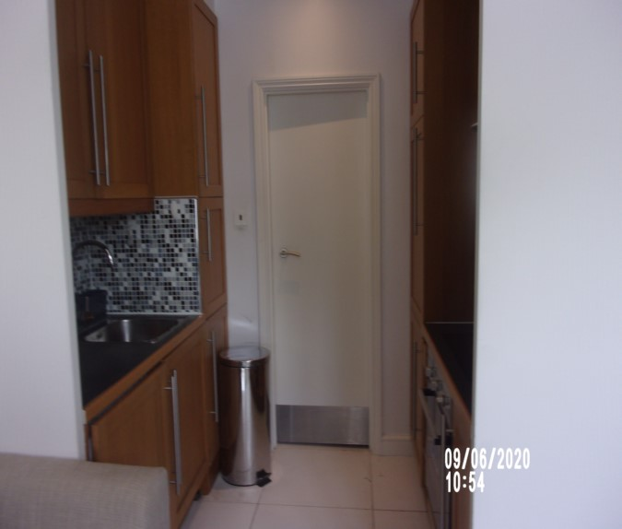 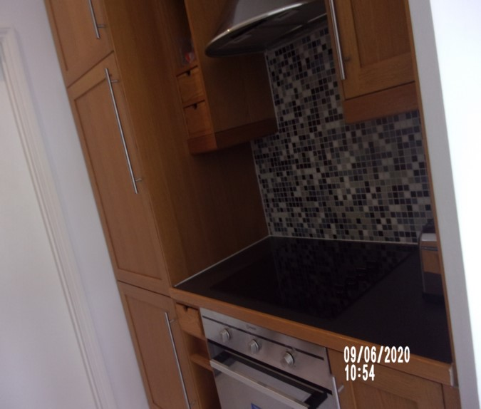

Kitchen Scuff wall

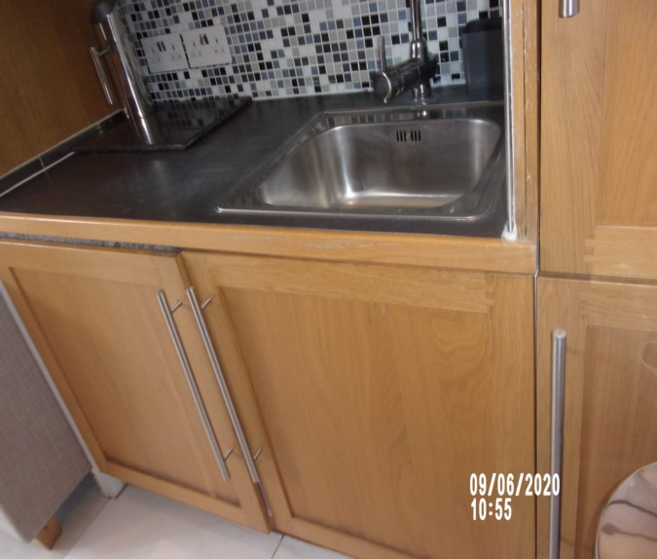 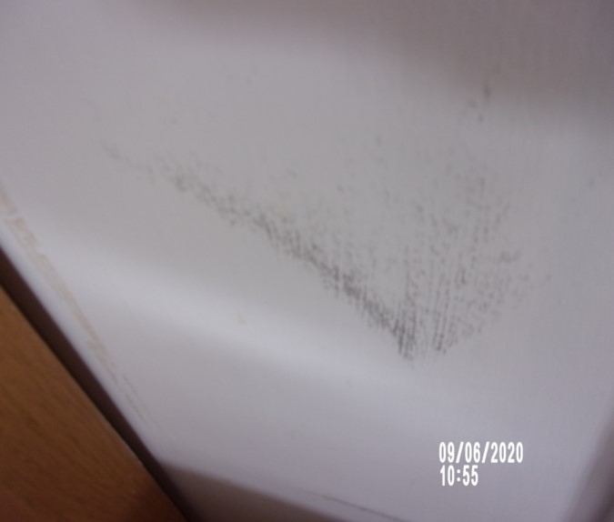

Kitchen Interior wall unit

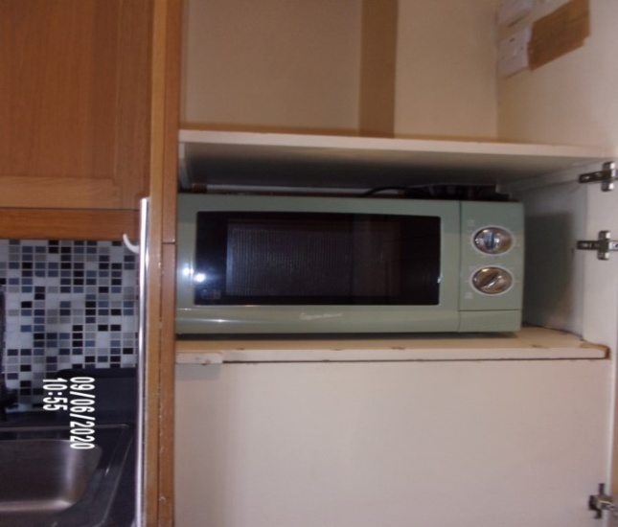 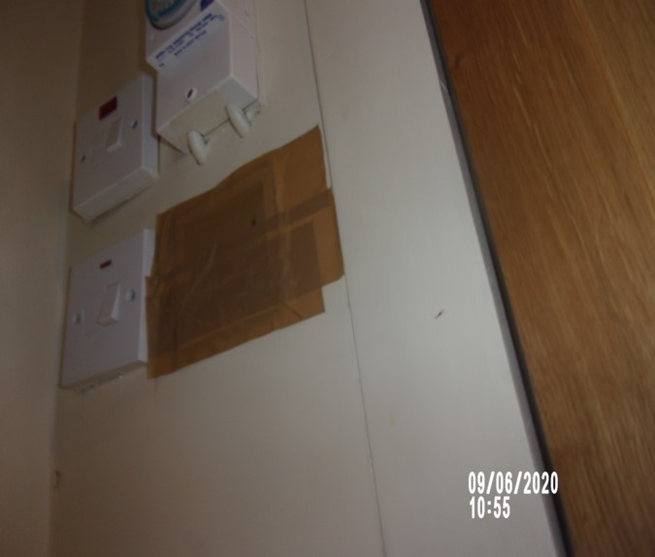

Chip interior wall unit Microwave

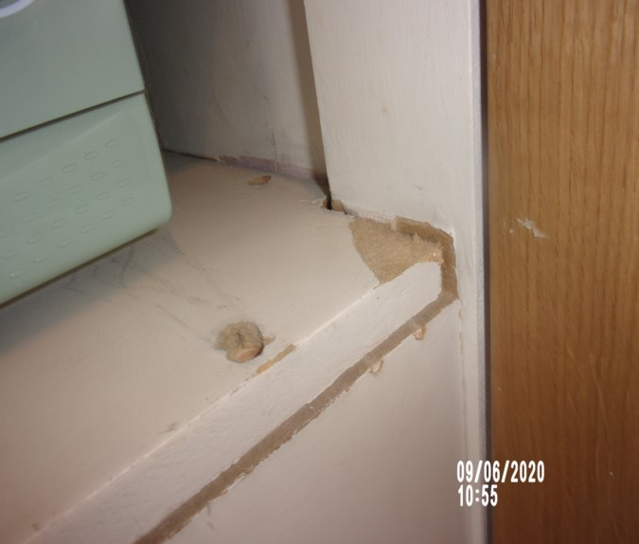 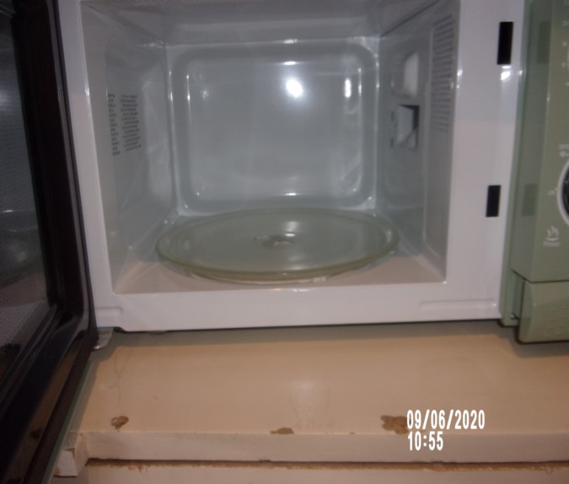

Water tank Sink

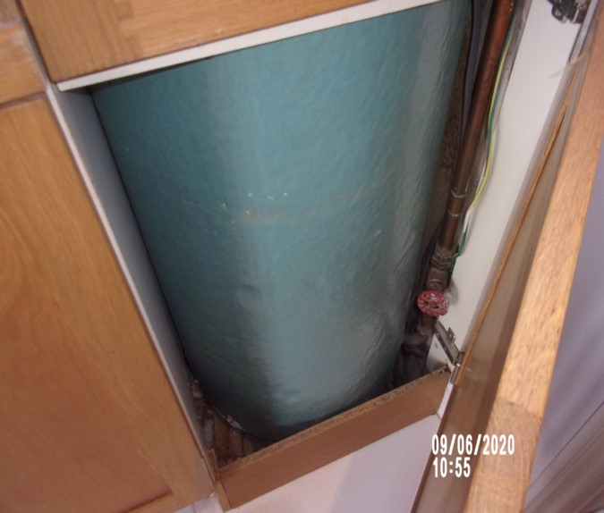 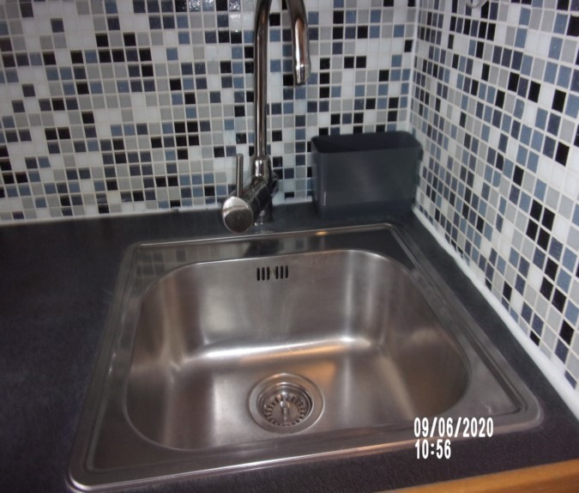

Washing machine Seal washing machine

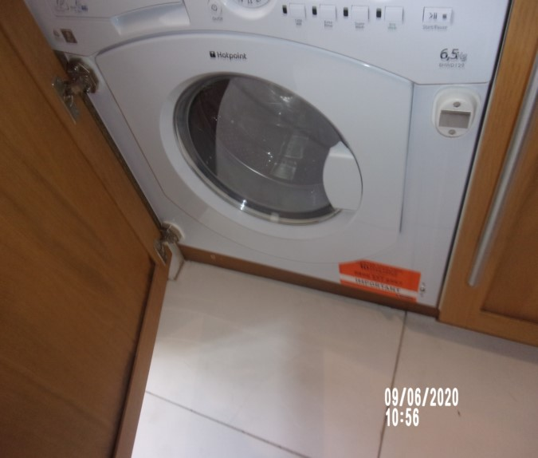 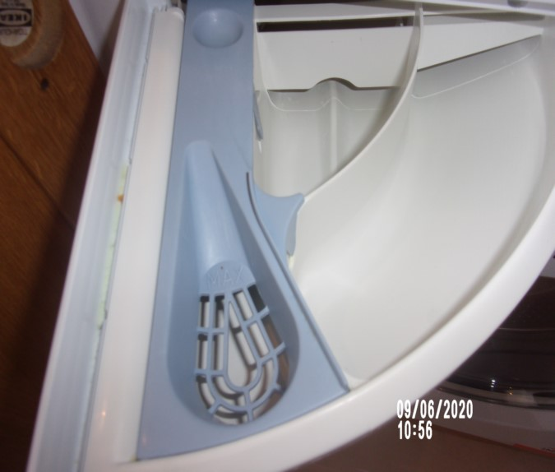

Seal washing machine Floor stain

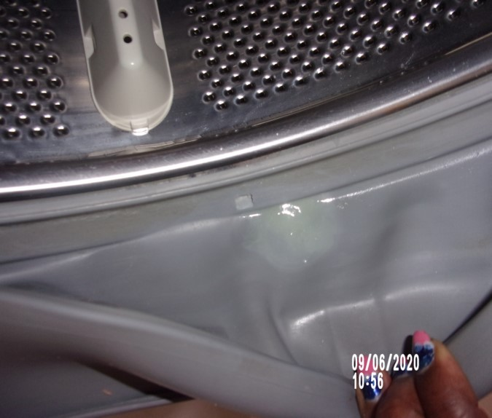 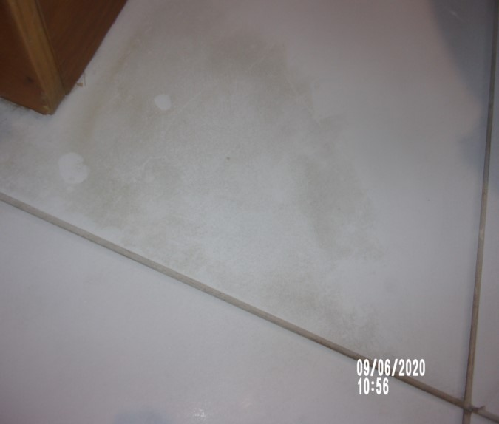

Crack floor tile Hob

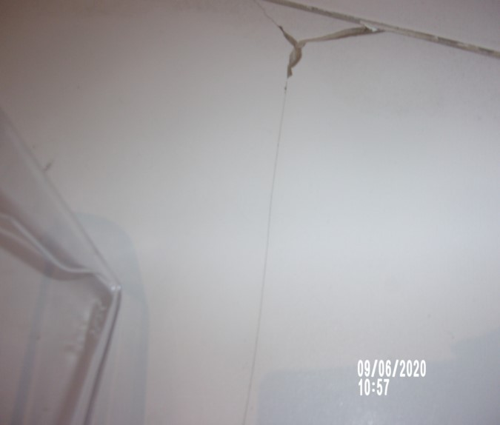 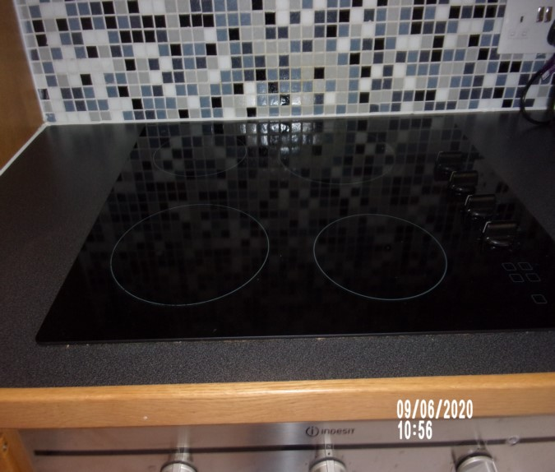

Extractor hood Oven

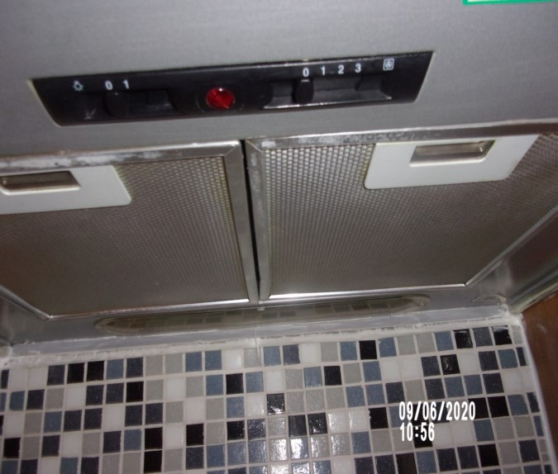 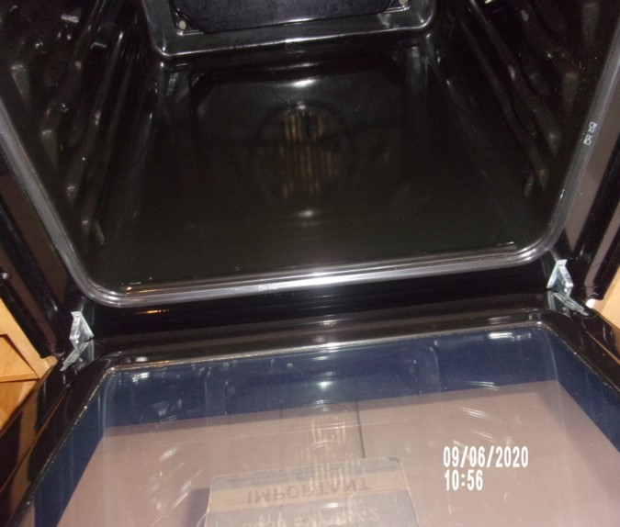

Items in high cupboard Fascia door detach fridge/ freezer

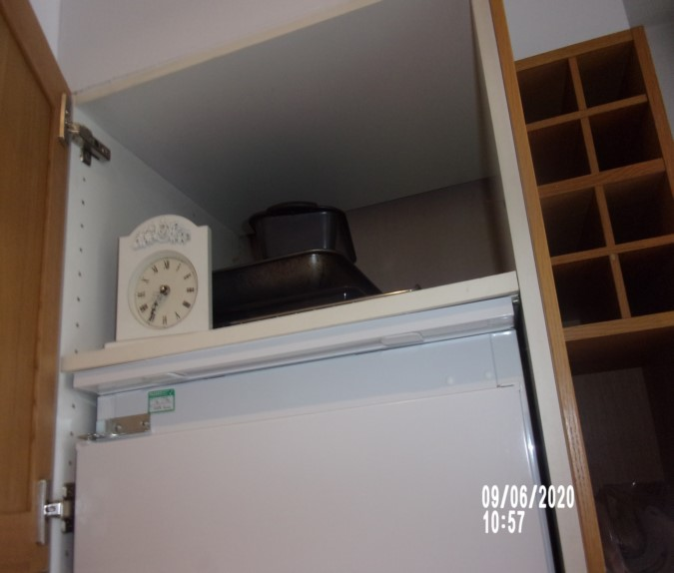 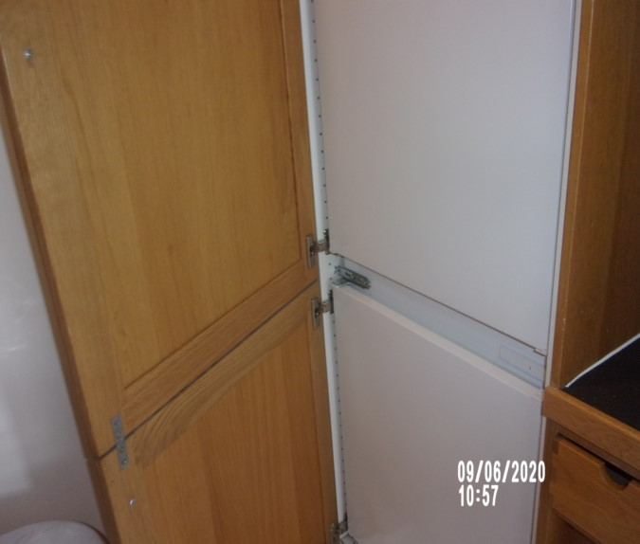

Fridge/ freezer

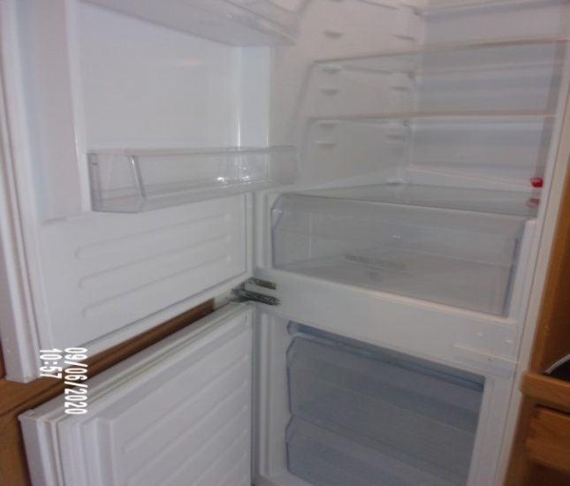

**SHOWER ROOM**

|  |  |  |  |
| --- | --- | --- | --- |
| **Door** | Door Frame exterior  Painted white  Metal kickboard low level | Minor spot marks to mid-level left hand side frame  1 or 2 x light scuff marks low-level left-hand side |  |
|  | Door Exterior  White painted flush door with brushed steel kick board  Brushed steel lever handle | Kick board slightly marked  Handle loose  Tarnishing seen to panel at low-level |  |
|  | Door Frame Interior  Painted white | 1 or 2 x light scuffs seen bottom right-hand side  Left-hand side some water damage  Few knot rings to frame |  |
|  | Door Interior  White painted flush door with brushed steel lever handle  2 x Chrome robe hooks  Brushed steel kick board | Cleaning required to panel at low-level  Slightly marked  Some light marking to leading edge interior  Handle loose |  |

**SHOWER ROOM**

|  |  |  |  |
| --- | --- | --- | --- |
| **Ceiling** | Painted white  1 x White plastic extractor fan | Tested and working  Yellow spot marks to the left-hand side of the shower area and the right-hand side  Scattered numerous discoloured marks and mould seen  Water staining seen to ceiling scattered throughout  Grey shading and finger soil marks scattered throughout |  |
| **Lighting** | 4 x White rimmed halogen bulbs | Working |  |
| **Walls** | Part painted white  Part off white ceramic tile with black / taupe circular design  Stainless steel panel behind W.C  Some non-matching plain white tiles to base of shower area and left hand side | 1. Grouting discoloured to shower area  2. Sealant very slightly marked to ledge behind sink  3. Some slight scratches and paint marks to ledge behind sink  4. Some filled chips to tiles low level in shower area  Some scuffing around radiator to painted section  Mould to grout  Heavy discolouration seen to grout in shower cubicle area  Right-hand side low-level 1 x chip |  |

**SHOWER ROOM**

|  |  |  |  |
| --- | --- | --- | --- |
| **Skirting** | Painted white | Some paint flakes to low level left hand side  Scattered minor marks  General scuffing in places |  |
| **Flooring** | Large off white ceramic tiles | 1. Couple of minor marks to left hand side of sink  Grout slightly diminishing and cracking  1 x tile cracked behind WC  Patchy appearance  Generally discoloured |  |
| **Heating** | Chrome wall mounted heated towel rail | Not tested |  |
| **Toilet** | White W.C with concealed cistern and white plastic seat and lid  Chrome wall mounted flush | 1. Tested and working  2. Paint marks and general light scratches to lid  3. Clean  Flush working – but difficult |  |
| **Sink** | White ceramic circular sink  Chrome waste  Chrome over flow  Chrome mixer tap  Sits on a :- table/ ledge | Some slight tarnishing to base of tap |  |

**SHOWER ROOM**

|  |  |  |  |
| --- | --- | --- | --- |
| **Ledge** | Brushed steel ledge set on wooden stand incorporating chrome towel rail | 1. 1 or 2 minor marks to ledge  2. Legs appear slightly loose  3. Towel rail marked  Left hand corner taped  Legs appear loose |  |
| **Shower** | Aluminium framed shower screen  1 x Fixed panel  1 x Sliding door with chrome handle  White plastic shower tray  Chrome waste  Chrome wall mounted control  Chrome wall mounted circular shower head | Water not tested  Opening door loose to lower not attached to runner  Showerhead lime scale |  |
| **Cabinet** | Wall mounted long mirrored fronted cabinet with chrome pull  Interior  3 x Chrome shelves  1 x Base shelf | 1. Minor slightly silvering to edges  2. General light usage marks to interior shelves  Requires further clean to interior corner |  |

**SHOWER ROOM**

|  |  |  |  |
| --- | --- | --- | --- |
| **Panel** | Low level white painted panel  Stopcock located to interior | 1. Paint work appears slightly patchy |  |
| **Mirror** | Fixed, unframed mirror | Good order |  |
| **Shelf recesses** | 2 x Tiled shelf recesses to shower area  White plastic tile trim to edges  White plastic plug drainer | 1. Tiles appear crazing to shelf and below right side shelf  Grout to seal, discoloured |  |
|  | Chrome bathroom tidy  Red and grey mop bucket |  |  |

Shower room Chip wall tile shower

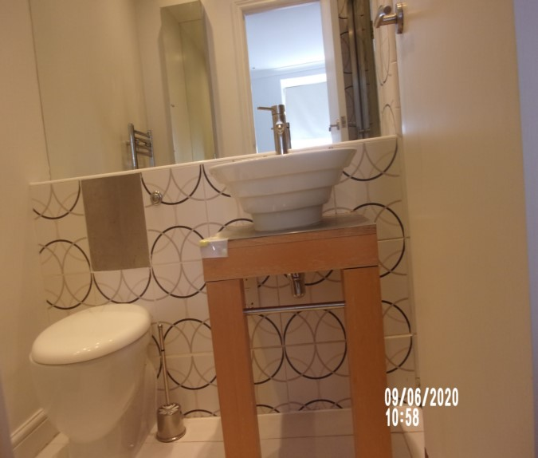 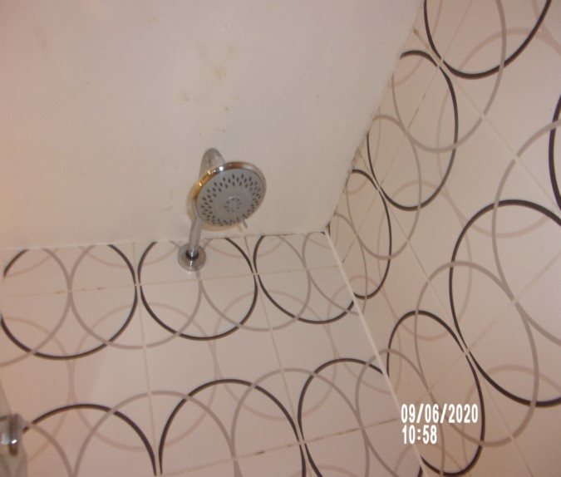

Shower room Ceiling stain

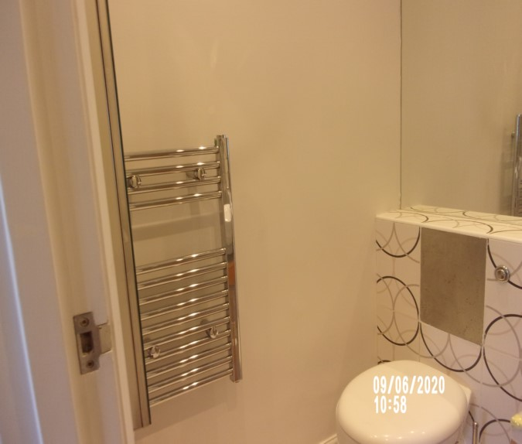 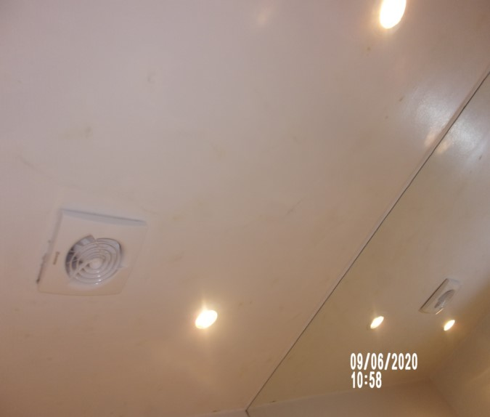

Tape to unit Shower room

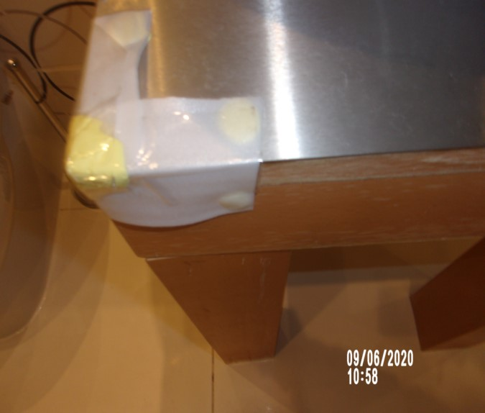 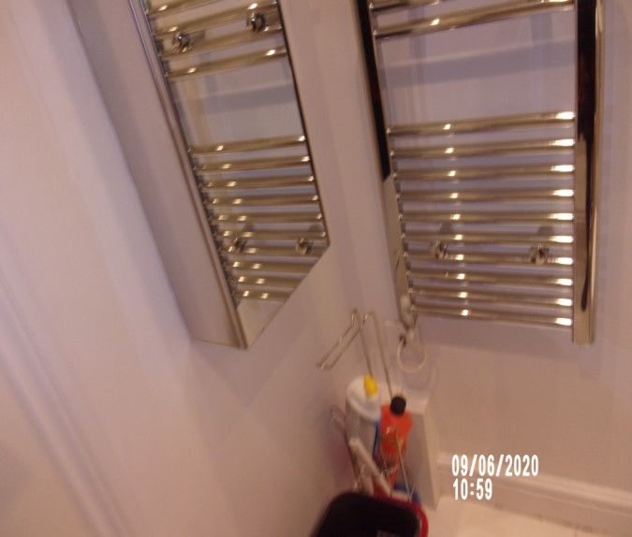

Tarnish behind WC Crack floor tile

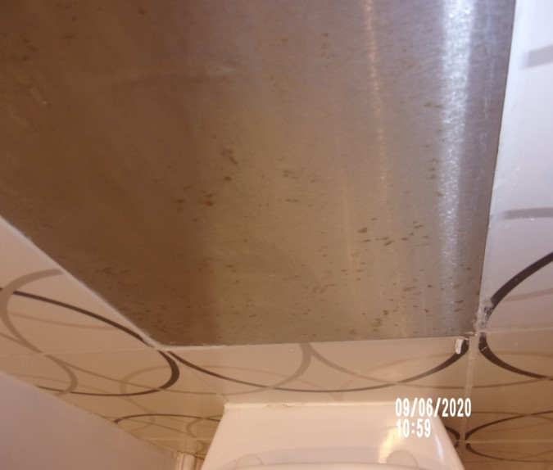 

Shower room

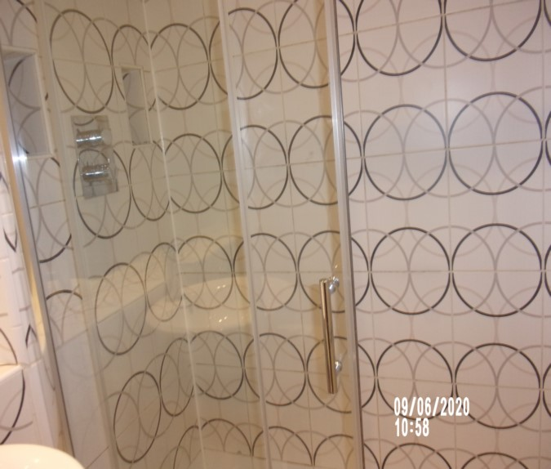

# DECLARATION AT CHECK IN

This inventory has been examined and, subject to marginal comments found to be correct.

## On behalf of the landlord

on behalf of the tenant _____

commencement of tenancy **______**

## **N.B**

This inventory is correct to the best of our knowledge but advise you to examine its contents prior to signing, as we can not be held responsible for any errors or omissions. Descriptions are for identification purposes only.

The relevant utility companies must check all meter readings, as we can not be held responsible for any discrepancies

**Please ensure that all items listed in this inventory are in the same location at the end of the tenancy.**

**ADDITIONAL AMENDMENTS**

|  |  |  |
| --- | --- | --- |
| DATE | DESCRIPTION OF CHANGES | AGENTS/LANDLORD SIGNATURE |
|  |  |  |
|  |  |  |
|  |  |  |
|  |  |  |
|  |  |  |
|  |  |  |
|  |  |  |
|  |  |  |
|  |  |  |

WHEN ADDITIONS/AMENDMENTS ARE MADE BY THE LANDLORD, TENANT OR AGENT THE RELATIVE PARTIES MUST BE INFORMED

**GENERAL COMMENT**

It should be noted that it is not the responsibility of the Inventory Clerk to open, unpack, empty or itemise items stored in carrier bags

or other containers unless it is made specifically clear they are the property of the Landlord.

|  |
| --- |
| **CHECK IN REPORT OF CONDITION AT: DATE:** 09/06/2020 |

|  |  |
| --- | --- |
| **PROPERTY ADDRESS:** | Flat A  40 Queens Gate Terrace  South Kensington  SW7 5PH |
| **CLIENT:** | London Central Portfolio |
| **CONTACT:** | Olivia Highwood |

|  |  |  |
| --- | --- | --- |
| **ELECTRIC** | **GAS** | **WATER** |
| **METER NUMBER:**  L86A15988 | **METER NUMBER:**  Unknown | **METER NUMBER:**  Unknown |
| **READING:**  Low: 64692  Normal: 37965 | **READING:**  Unknown | **READING:**  Unknown |
| **LOCATION:**  Communal hall on entry | **LOCATION:**  Unknown | **LOCATION:**  Unknown |

|  |  |  |  |  |  |  |
| --- | --- | --- | --- | --- | --- | --- |
| **PROPERTY DESCRIPTION** | | | | | | |
| **ROOM** | **QTY** | **ROOM** | | **QTY** | **EXTERIOR AREAS** | **QTY** |
| RECEPTION | 1 | BATHROOMS | | 1 | FRONT GARDEN | 0 |
| OFFICE | 0 | WC | | 0 | REAR GARDEN | 0 |
| BEDROOMS | 1 | UTILITY | | 0 | SWIMMING POOL | 0 |
| DRESSING ROOM | 0 | STORE ROOM | | 0 | GARAGE | 0 |
| STAIRCASE & LANDINGS | 0 | CELLAR | | 0 | ANNEX | 0 |
|  |  |  | |  |  |  |
| □ HOUSE □ FLAT | | | □ UNFURNISHED □ FURNISHED | | | |

|  |
| --- |
| **GENERAL SUMMARY** |

|  |  |  |
| --- | --- | --- |
| **GENERAL CONDITION** | □ Professionally cleaned for start of tenancy :-  □ Domestically cleaned for the start of tenancy :-  □ Further general cleaning required:-  □A full professional clean is required :- | **FURTHER COMMENTS** |
| **ODOUR** | □ Pet □ Smoking □ Cooking  □Musty | □N/a |
| **DECORATIVE ORDER / WOODWORK** | □Advised freshly painted  □Good Order  □ Defects as noted  □ Dusty  □Woodwork scuffed/chipped |  |
| **FLOORING** | □Professionally cleaned for start of tenancy  □Good Order□ Defects as noted  □ Vacuumed for start of tenancy  □Requires further cleaning □ New |  |
| **CURTAINS / BLINDS** | □ Professionally cleaned for start of tenancy  □ Vacuumed insitu for start of tenancy  □Requires further cleaning  □Defects as noted□Good Order | □N/A |
| **BLIND REGULATIONS** | □Chain break connector in place  □Chain Tidyin place  □Regulations not met | □N/A |
| **UPHOLSTERY** | □ Professionally cleaned for start of tenancy  □ Vacuumed insitu for start of tenancy  □Good Order  □ New □ Defects as noted | □ N/A |
| **FFR LABELS** | Sofa □ FFR Label Seen □ Label Not seen Armchair □ FFR Label Seen □ Label Not seen Pouffee □ FFR Label Seen □ Label Not seen  **Mattress:**  Bed 1 □ FFR Label Seen □ Label Not seen Bed 2 □ FFR Label Seen □ Label Not seen Bed 3 □ FFR Label Seen □ Label Not seen Bed 4 □ FFR Label Seen □ Label Not seen  **□ Client informed Name……………………….……** |  |
| **LINEN** | □ New □ In use □ None provided  □Domestically cleaned □ Freshly laundered | □ Requires further cleaning |
| **LIGHTS** | □ All working order  □ Bulbs missing / not working |  |
| **KITCHEN / APPLIANCES** | □ All clean order  □ All Appliances power tested  □Fridge left open power off □Freezer left open power off  □Fridgeleft shut power on □Freezer left shut power on | □ Requires further cleaning |
| **BATHROOMS/**  **WC** | □ Clean □ All fitments free of lime scale  □Water outlets tested and working | □ Mildew to areas as noted  □ Requires further cleaning |
| **WINDOWS** | □ Fitments complete  □ Clean to interior □Clean to exterior | □ Requires further cleaning |
| **GARDEN /**  **TERRACE/**  **BALCONY** | □ Seasonal order | □ N/A  □Further attention required |

|  |
| --- |
| **POSITION OF** |

|  |  |
| --- | --- |
| **STOP COCK** | Bathroom low level cupboard |
| **FUSE BOARD** | Hallway high level cupboard |
| **ALARM PANEL** | None |

|  |
| --- |
| **MANUALS PROVIDED** |
| **□** Washing machine □ Alarm □ TV □ Tumble Dryer □ Boiler □ Extractor hood  □ Dishwasher □ Microwave oven □ Oven  □ Fridge freezer □ Phone □ Waste disposal  □None provided |

|  |
| --- |
| **FIRE SAFETY** |

|  |  |
| --- | --- |
| **SMOKE ALARM 1** | □ Mains powered □ Power light on □ Too high to read □ Not visible  □**T**ested with Canned smoke and working order  □**Location: -** ……………………………………………………..  □**Expiry date** ………/…………/……..  **□ SMOKE ALARM NOT WORKING – Agentadvised**  Person advised: - Name ……………………………… |
| **SMOKE ALARM 2** | □ Mains powered □ Power light on □ Too high to read □ Not visible  □Tested with Canned smoke and working order    □**Location: -** ………………………………………………………….  □**Expiry date** ………/…………/……..  **□ SMOKE ALARM NOT WORKING – Agentadvised**  Person advised: - Name ……………………………… |
| **SMOKE ALARM 3** | □ Mains powered □ Power light on □ Too high to read □ Not visible  □Tested with Canned smoke and working order  □**Location**: - ………………………………………………………………  □**Expiry date** ………/…………/……..  **□ SMOKE ALARM NOT WORKING – Agentadvised**  Person advised: - Name ……………………………… |
| **CARBON MONOXIDE ALARM** | □ Tested and working order □Light seen □N/a |

|  |  |  |  |
| --- | --- | --- | --- |
| **KEYS** | | | |
| **KEY TYPE** | **SERIAL NUMBER** | | **QTY** |
| Jma Yale |  | | 1 |
| Banham – flat door | 0587385 | | 2 |
| Banham | 64D 5708 | | 2 |
|  |  | |  |
|  |  | |  |
| **KEYS RECEIVED BY:** □AGENT □TENANT □LANDLORD □CONCIERGE □BUILDER  □ Management keys used □ None provided  *Tick as applicable | | | |
| **NAME PRINTED:**    **……………………………………………………..** | | **SIGNATURE :**  **…………………………………………………….** | |

*N.B – Heavy items will not be moved or inspected behind/under, for health & safety reasons. We will not be held liable should any damages/stains/marks be found during the tenancy in these areas. Should the occupant find any of the above they should, inform the landlord/agent immediately and if/where possible take photographic evidence and pass to the relevant parties.

|  |  |  |
| --- | --- | --- |
| **CLIENT CALLED AT** | | |
| **TIME:** | **VOICE MESSAGE LEFT FOR:** | **SPOKEN WITH:** |

|  |  |  |
| --- | --- | --- |
| **IN ATTENDANCE AT CHECK IN** | | |
|  **INDEPENDENT CLERK**  ** TENANT**  ** LANDLORD**  ** AGENT** | **NAME PRINTED**    ……………………………………………… | **SIGNATURE**  ……………………………………..………….. |

|  |
| --- |
| **In attendance:** □LANDLORD □TENANT □INVENTORY CO. □RELOCATION REP |

|  |  |
| --- | --- |
| **NAME PRINTED**    ………………………………..……………… | **SIGNATURE**    ………………………………..……………….. |